
LoW LEVEL DESIGN(LLD) FOR Automation and ORCHESTRATION(AnO)-Network services orchestrator (NSO) APPLICATION
Tender Ref. No.: TSTS/CS/RFP-T-FIBER-MSI/2018)
Telangana Fiber Grid Corporation Ltd
(T-FIBER)
Government of Telangana

October 21, 2025

Revision No. | Date of Submission | Description of Revision |  | Prepared  By |  | Date of submission for Review | Review completed Date
0.1 | 9-8-2021 | Initial Version |  | Sidharth Jain (Engineer Architect)  Pooja Pathak (Engineer Software)  Rishikesh Sawant (Architect, Solution Design)  ASHISH CHANDRA BARANWAL (E2E Application Integration Architect)
0.2 | 31-12-2021 | Draft incorporating review comments |  | Sidharth Jain (Engineer Architect)  Pooja Pathak (Engineer Software)  Rishikesh Sawant (Architect, Solution Design)  ASHISH CHANDRA BARANWAL (E2E Application Integration Architect)
0.2 | 29-10-2025 | Draft for Review and Approval |  | L&T |  | 29-10-2025
Prepared by |  |  | Reviewed By |  | Approved by
Ritik Sujit (NSO) |  |  | Jayant Madavi (NSO)  RS Rao (Networks SME) |  | Sandeep Deshmukh  Siva Prasad Yeparala

Contents
1. Overview 4
2. Operations and Business Support Systems 4
2.1 OSS – Operations Support System 5
2.2 BSS – Business Support System 5
3. Tfiber Network Architecture 6
4. Service Design 8
4.1 Broadband Services (Resi) 8
4.2 TCell 9
4.3 CCTV 11
4.4 L3VPN 13
4.5 L2VPN 14
4.6 GI-BB (Internet for Government offices) 15
4.7 VOIP 16
4.8 CIENA 17
5. IP Addressing schemes 17
6. Route- Targets (RT)& Route-distinguishers (RD) 18
7. Artifacts 19
8. NSO Solution Overview 19
8.1 Product Overview 19
8.2 Architectural Overview 20
9. SCCM Solution Overview 23
9.1 Service Configuration and Compliance Manager 23
9.2 Device addition into SCCM – NSO 25
9.3 System requirements 26
9.4 Platform Details 27
10. L2VPN/L3VPN Use-Case Service Requirements 28
10.1 Device Types 28
10.2 Network reachability 28
10.3 Service requirements 29
10.4 Service Catalogue 30
10.5 Service Input Variables 33
Cisco (L2VPN) Service Input Variable (User / System Defined) 34
Cisco (L3VPN) PE-CE Protocol Service Input Variable 34
11. Cisco Solution 36
11.1 SCCM-NSO Solution Deployment Methodology 36
11.2 Solution Provisioning Flow 38
11.3 API flow between SCCM and NSO 39
11.4 NSO Service Package structure and details 40
11.5 SCCM API Document 71
12. Appendix 72
12.1 Service Templates 72

- Overview
This document describes T-Fiber IP/MPLS Transport network which will be used as a common IP transport infrastructure that shall cater to services using last mile access technologies such as Wi-Fi and FTTH. The overall design will cater to services for Government and Enterprise customers.
The purpose of this Low Level Design Documentation (LLD) is to document the solution vis-à-vis the design for the purpose of service orchestration using Cisco’s Network Service Orchestrator. This document describes design details of the Cisco Network Service Orchestrator (NSO) solution along with SCCM (Service Configuration and Compliance Manager) for the network services provisioning in the Tfiber network. This document is primarily service oriented and will focus on network automation.

The intended audience of this document are:

- Tfiber Project Team
- Integration Partners
- L&T

- Operations and Business Support Systems

This section explains the OSS and BSS connectivity to SCCM

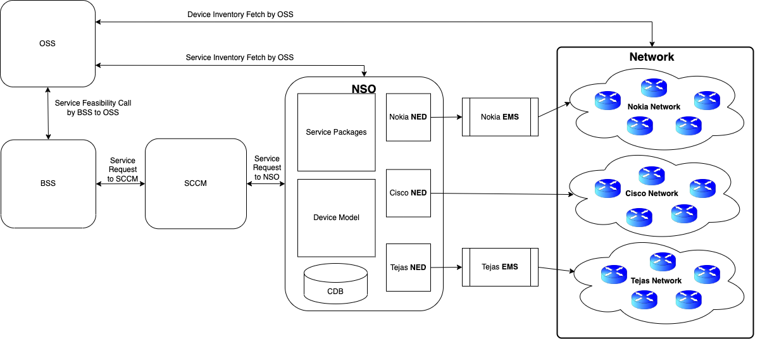
Figure 1 : OSS & BSS North Bound Connectivity with SCCM

  - OSS – Operations Support System

OSS Maintains the Device Inventory and the Service Inventory for all the devices. OSS connects to SCCM with the help of North Bound APIs. Below is the SCCM-NSO North bound API Document for OSS.

  - BSS – Business Support System

All Orders are placed from BSS and then BSS hands those order to SCCM-NSO for Provisioning after a feasibility check with OSS based on Lat/Long of the Location of Request, it also holds the Billing system. BSS communicates with SCCM-NSO via North Bound APIs Exposed to BSS by SCCM and other call back APIs. Below is the SCCM-NSO North bound API Document for BSS.

- Tfiber Network Architecture

Tfiber is Telanga wide fiber optic based network deployed under Bharatnet, where core is from Cisco and access network primarily on GPON network. GPON is from Nokia and Tejas Networks.

Tfiber network is built on IP/MPLS core and GPON as access network to serve following services – :

- HSI- (L2 Service)
- Tcell- (L2 Service)
- CCTV- (L3 Service)
- L3VPN- (L3 Service)
- L2VPN- (L2 Service)
- GI-BB- (L3 Service)
- VOIP- (L2 Service)
- CIENA- (L2 Service)
Automation scope is to automate above services.

Tfiber High level Architecture – :

Tfiber network is seamless MPLS based architecture. Benefit of such architecture is, it restric failure domains and more scalable. End to end reachability is achieved by using BGP based label-unicast.

Figure 2 : IGP Design
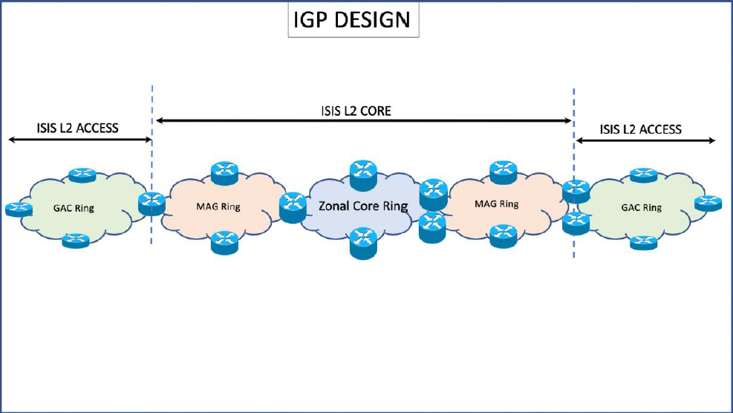

- Service Design
  - Broadband Services (Resi)

Internet is provided by 3rd party service provider connected to Tfiber network vis L2 interconnection (with designated Internet Services Provider).

Following are the Solutions on T-Fiber network to transports the services to Subscribers.

A- L2VPN (VPWS) NNI with multiple sub-interfaces.
B- L2VPN (VPLS) Hub & Spoke

Figure 3 : HSI IP MPLS

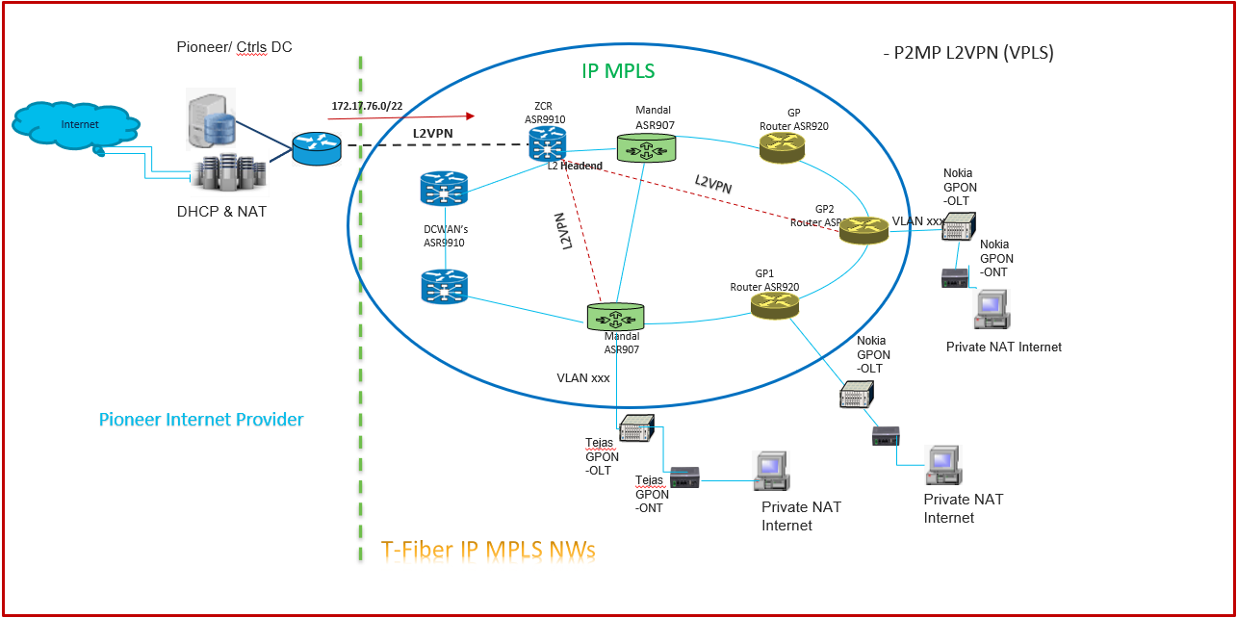

  - TCell

T-Fiber underground OFC network offering highspeed and secured L2 VPN Point to Multipoint solution provides an opportunity to cellular operators to reliably connect the remote cell sites. Following are the T-Cell Product Components offering L2 VPN Point to Multipoint.

A: Central Site (Hub)

1. External Network to Network Interface (ENNI)

B: Cell Tower Sites (Spoke):

1. User Network Interface (UNI)
2. Access Virtual Circuit (AVC) Bandwidth
3. Last Mile Network Connectivity (LMN)

Figure 4 : TCELL Construct

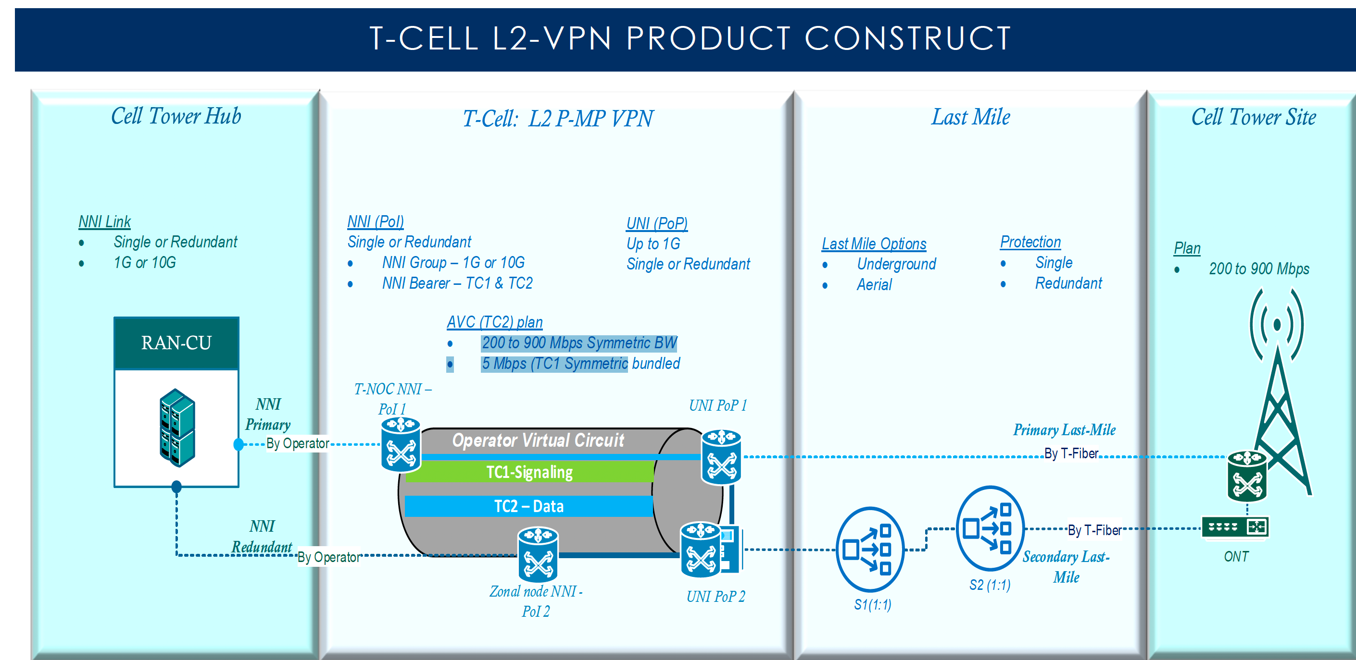

There are multiple scenarios, as of now we have automated Single HUB / Static HUB and single last mile on fiber.
QoS has been defined and applied as per the Tfiber requirement.
We have below Testcase with QOS to execute Tcell Connectivity in the production.

- TCELL-ASR920-SINGLE- QOS
- TCELL-ASR907-SINGLE-QOS
- TCELL-ASR9K-SINGLE -QOS
- TCELL-ASR920-SINGLE-MULTIPORT -QOS
- TCELL-ASR907-SINGLE-MULTIPORT -QOS
- TCELL-ASR9K-SINGLE-MULTIPORT -QOS

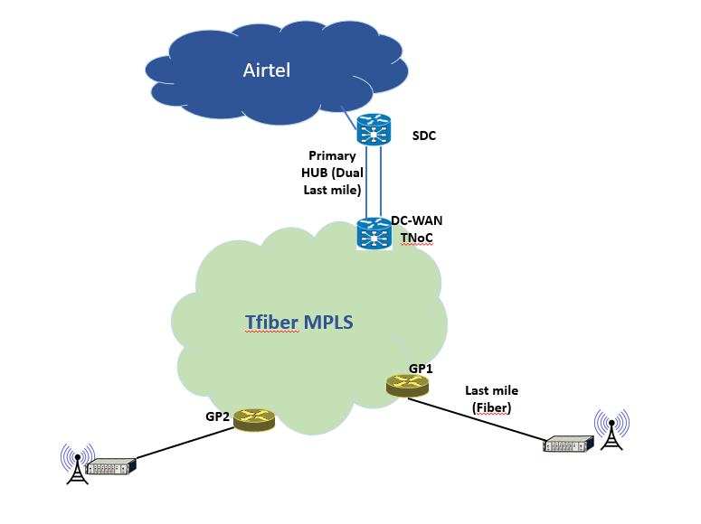

  - CCTV
Tfiber CCTV network will be based on multicase profile - Multicast (MVPN) profile 0​

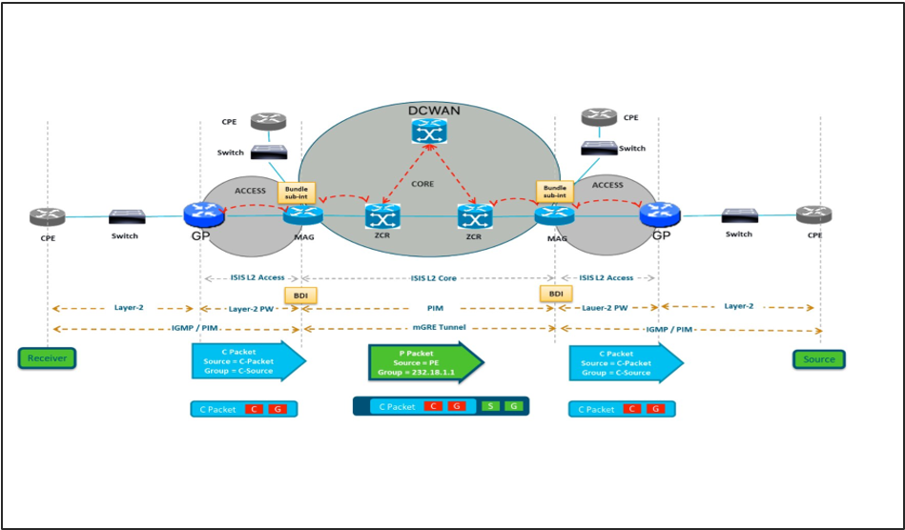

Figure 5 : CCTV

In Profile 0 the Generic Routing Encapsulation (GRE) as an overlay protocol. That means that all multicast packets are encapsulated inside GRE. A virtual LAN is emulated with all Provider Edge (PE) routers in the VPN join a multicast group. This is known as the default Multicast Distribution Tree (MDT). The default MDT is used for Protocol Independent Multicast (PIM) hello and other PIM signalling but also for data traffic. If the source sends a lot of traffic, it is inefficient to use the default MDT and a data MDT can be created. The data MDT will only include PE’s that have receivers for the group in use.

- The solution proposed from T-Fiber IP-MPLS Network prospect is GRE based SSM Multicast Full Mesh L3VPN (MVPN).​
- The last mile connectivity is considered on GP, MAG directly or via GPON, PW would be created between GP-MAG ​and MVPN VRF would be created on MAG.​
- The full Mesh MVPN (Rosen Draft-GRE based) with PIM SSM would be created between all MAG and ZCR.​
- The customer CPE L3 termination will be either Cyberabad DC GP router (MVPN vrf) : PIM SM, IGMP V3 ​

BGP would be used as CE-PE protocol between Cyberabad GP router to DC1 & DC2.​
- The Receiver will request IGMP v3 for the specified multicast group.
- The NVR/Cameras should be configured with multicast IP and IGMPv3.

Final CCTV architecture -:

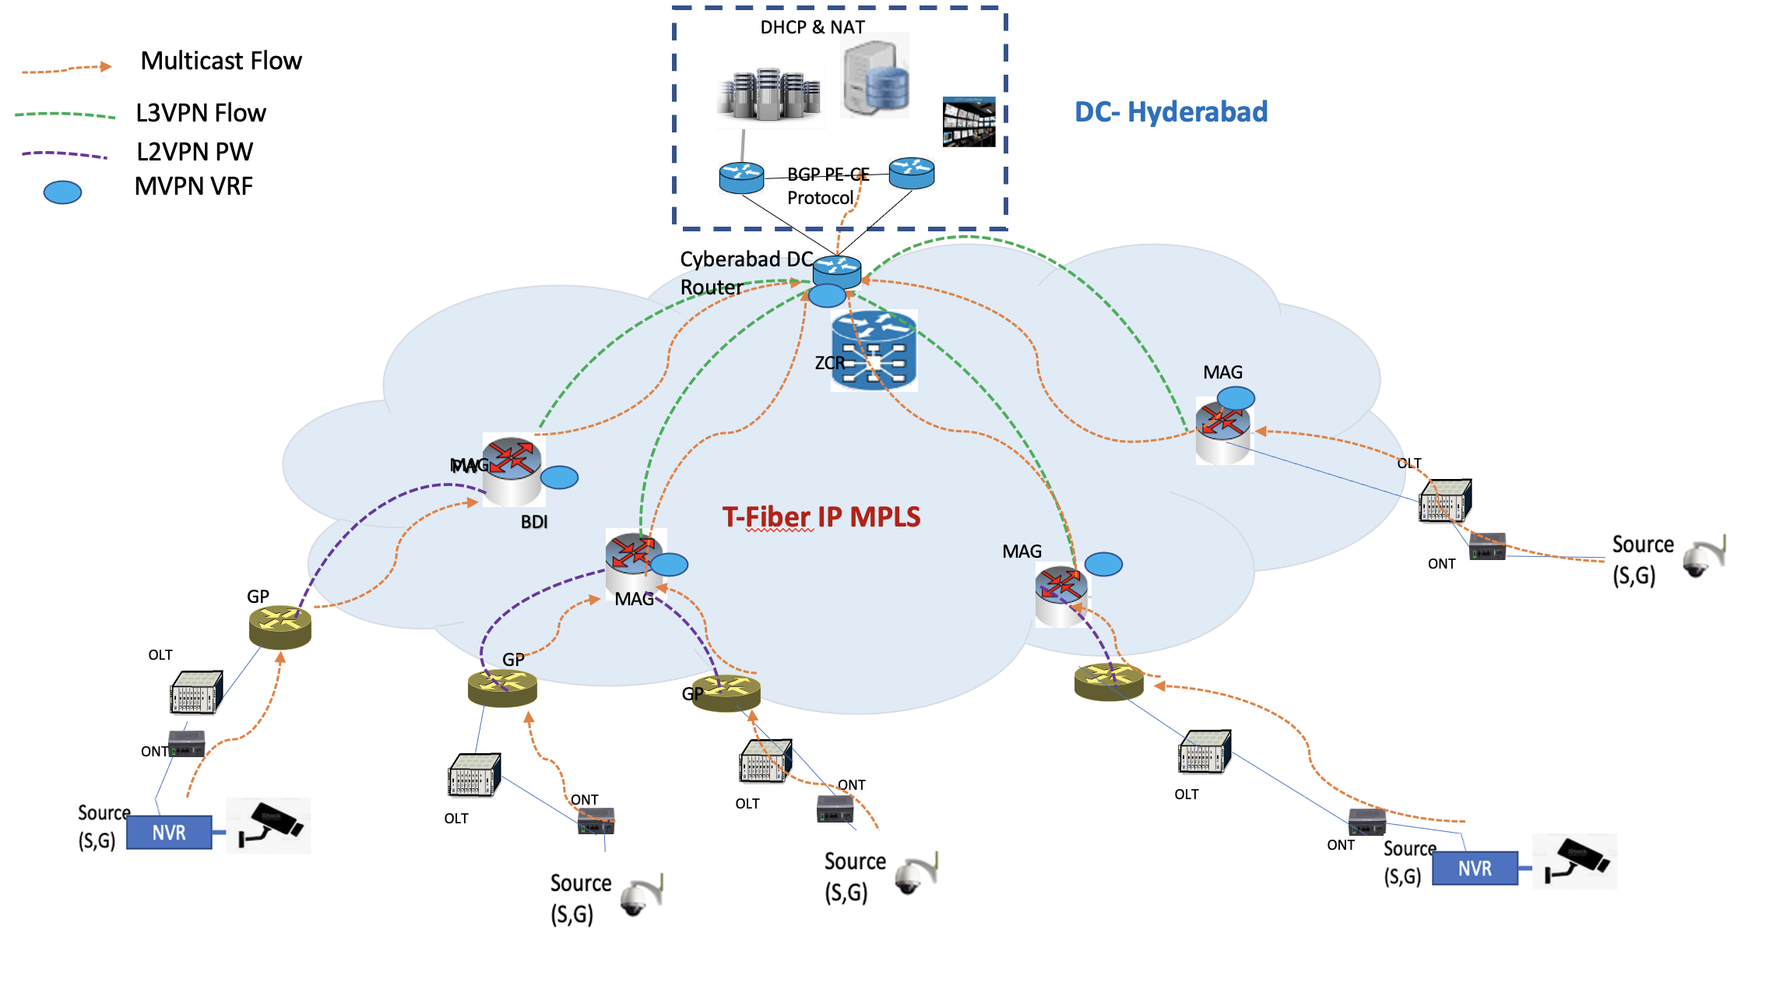

  - L3VPN

L3VPN service is used for enterprise customers want to connect multiple branch offices over layer3. The service provider will participate in routing with the customer. The customer has an option to run OSPF, tatic routing or BGP routing protocol with the service provider.
- VPN: routing information from one customer is completely separated from other customers and tunneled over the service provider MPLS network.
- VRF: This is the first step in separating traffic from different customers. Instead of using a single global routing table, we use multiple routing tables. Each customer of the service provider will use a different VRF.
Figure 6 : L3VPN Topology

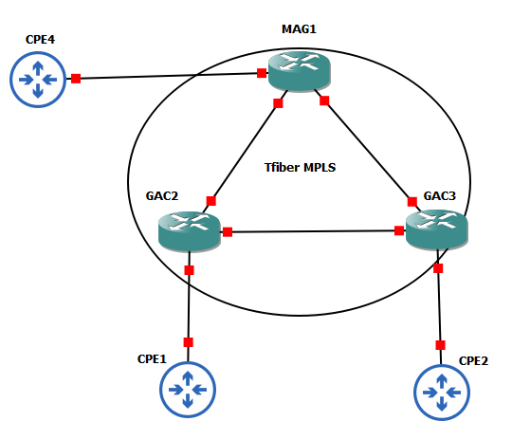

  - L2VPN

MPLS L2VPN provides Layer 2 VPN services on the MPLS network. It allows customers to establish L2VPNs on L3 MPLS VPN network.

MPLS L2VPN transfers Layer 2 user data transparently on the MPLS network. For users, the MPLS network is a Layer 2 switched network and they can establish Layer 2 connections over the network.

Figure 7 : L2VPN Topology
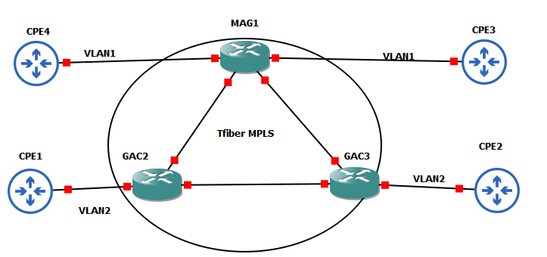

  - GI-BB (Internet for Government offices)

In GI-BB service, Internet is provided to Government offices and T-Fiber acts as ISP to government offices. To provide GI-BB services, each customer traffic is passed through the Firewall to ensure security and firewall is connected to ZCR router, which in turn connected to Internet.

This is a hub & spoke deisng and following is the RT confgured on ZCR router.
As of now we have automated Single HUB / Static HUB with single GPON lastmile.

address-family ipv4
route-target export 141688:31
route-target import 141688:32
exit-address-family
on PE routers, connected to CPE, reverse RT of Hub will be q qconfigured i.e.
address-family ipv4
route-target export 141688:32
route-target import 141688:31
exit-address-family

Figure 8 : GI-BB Topology
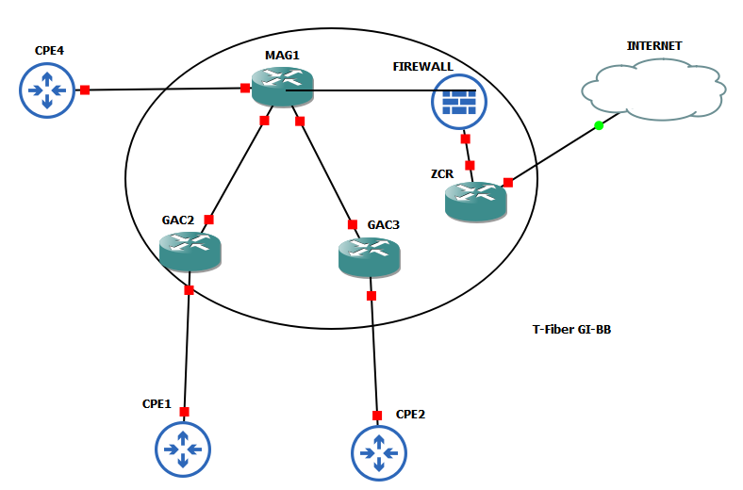We have below Testcase to execute GI_BB services in the production.
- GI-BB-TEJAS-SINGLE-ASR920
- GI-BB-TEJAS-SINGLE-ASR907
- GI-BB-NOKIA-SINGLE-ASR907
- GI-BB-NOKIA-SINGLE-ASR920
- GI-BB-ASR9K-SINGLE-BGP-HUB

  - VOIP

VOIP service is achieved using MPLS L2VPN services of T-fiber network. IMS / VOIP servers are connected to core routers and there is end to end L2VPN from end customer to ZCR (headend router connected to IMS).

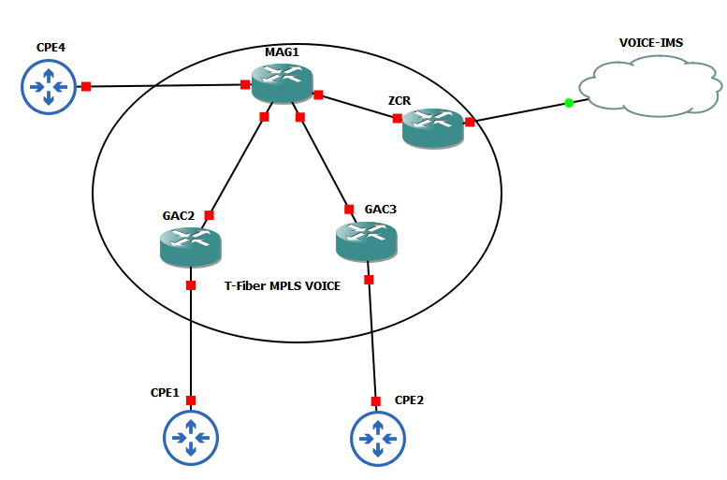

Figure 9 : VOIP Topology
VOIP follows the L2VPN model similarto HSI.

  - CIENA
Ciena - this setup is required if the customer asks for large bandwidth e.g. 10G or more. There are two options to provide L1 bandwidth (on the optical network) to the customer -:

1 - Using DWDM

2- OADM

if, bandwidth asked by the customer is low i.e. 1G to 10G, OADM will be used, if available. Else, DWDM will be used to connect to customer office directly.

Figure 10 : Ciena Topology

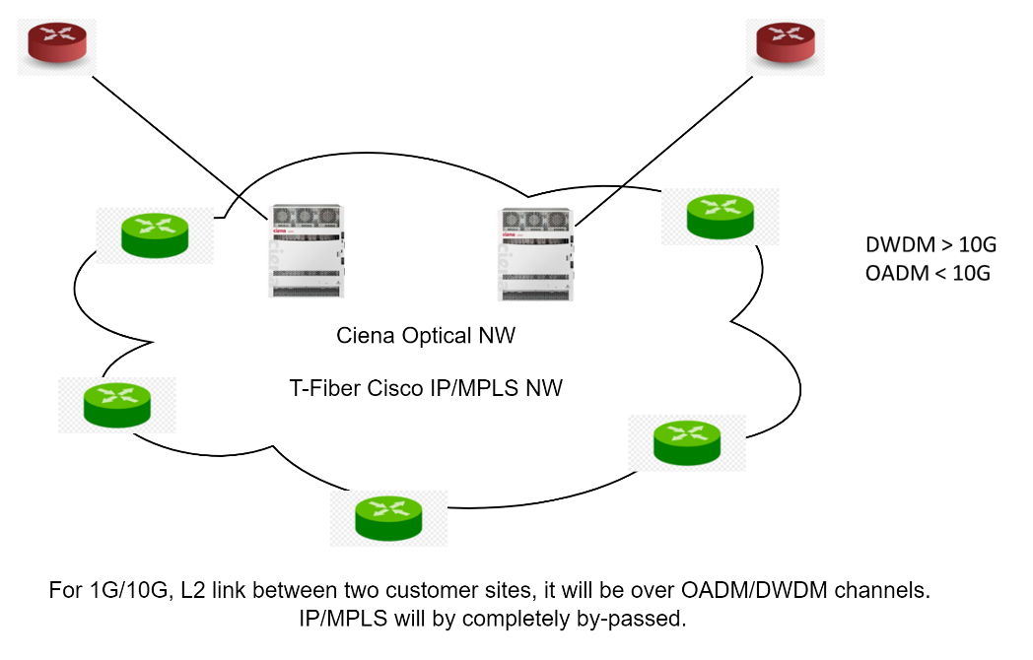

  - T-DIA
T-DIA internet leased line service offering to Enterprise, Government Instiutions
Scenario – 1 GP/Mandal router acting as GW for cumstomer LAN.
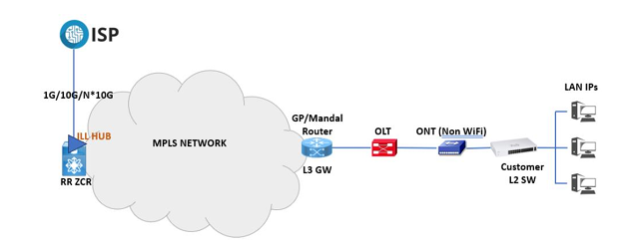

Scenario – 2 Customer end CPE is connected to GP/Mandal router on WAN. Static routing between PE & CE for LAN IPs.
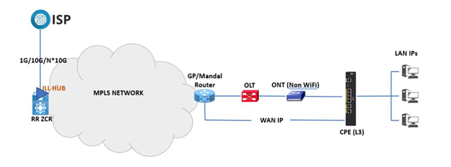

Scenario - 3 WiFi ONT in router mode acting as NAT+GW. One public IP from /30 is assigned to WiFi ONT and other public IP in this /30 is assigned to GP/Mandal router interface which is acting as GW for WiFi ONT.
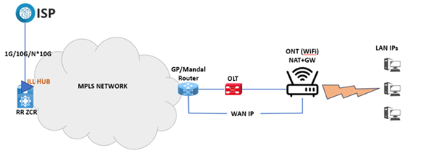
Scenario – 4 WiFi Router as NAT+GW for customer LAN. One public IP from /30 is assigned to WiFi Router and other public IP in this /30 is assigned to GP/Mandal router interface which is acting as GW for WiFi Router.

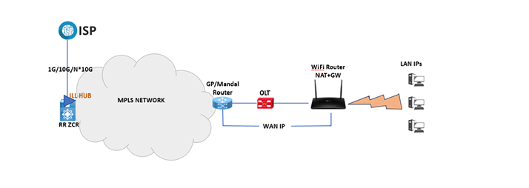

Scenario - 5 Customer has own CPE and Last mile on Fiber (single/dual)
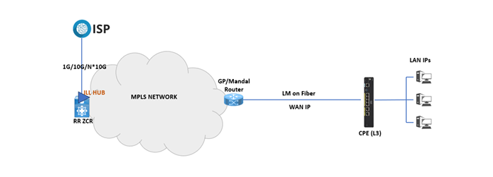

Scenario – 6 Customer has own Public IP pools (and own router) and doing BGP with TFiber.
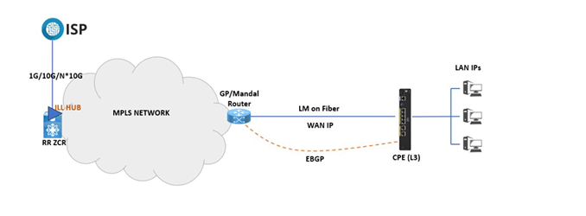

- IP Addressing schemes
For Internal Service – 172.24.0.0/16; 172.25.0.0/16
For External service – 172.22.0.0/16; 172.23.0.0/16
We are awaiting for the conformation on the above IP pols from end customers. Above one was proposed in LLD. For GI – 10.10.0.0/16 further subneted to /28 for each customer.
- Route- Targets (RT)& Route-distinguishers (RD)

Initial recommendation in LLD for RT was as below -:

SR.No | RT | Customer | Comments
1 | 1-100 | Internal Service | Internal service like MGMT
2 | 101- 4999 | Internal Customers | Internal customer like Govt Services like G to G, G to B
3 | 5000- 9999 | External customers | External VPN Customers C to C, G to C
4 | 10000-65535 | Reserved | Reserved

If there are any further changes on the RT/RD, end customer will update Cisco NSO team to reconfigure.

- Artifacts
Here are the test cases executed in lab.

- NSO Solution Overview
  - Product Overview
The industry is rapidly moving towards a service-oriented approach to network management, where complex services are supported by many different systems. To manage these, operators are starting a transition from managing pieces of equipment towards a situation where an operator is actively managing the various aspects of services.

Configuring the services and the affected equipment are among the largest cost-drivers in provider networks. Still, the common configuration management practice involves pervasive manual work or ad hoc scripting. Why do we still apply these sorts of techniques to the configuration management problem? Two of the primary reasons are the variations of services and the constant change of devices. These two underlying characteristics are, to some degree, blocking automated solutions, since it takes too long to update the solution to cope with daily changes.

Time-to-market requirements are critical for a new service to be deployed quickly and the delay in configuring the corresponding tools has a significant impact on revenue. There is an un-served need in provider networks for tools that address these complex and sometimes contradictory challenges while constructing service configurations.

In the past several years Software-Defined Networking (or SDN) has emerged as a solution. The purpose of SDN is to provide a centralized, unified set of APIs with which networks and services can be controlled by software – automatically and in real time. The promised benefits include faster and more precise control of networks and services leading to higher performance and lower costs.
Network Services Orchestration (NSO) enables operators to dynamically adopt the service configuration solution according to changes in the offered service portfolio. It delivers the SDN vision today in providing a logically centralized interface towards the multi-vendor network. The network can be a mix of traditional equipment and virtual devices.

  - Architectural Overview
Figure 11 : NSO Functional Architecture
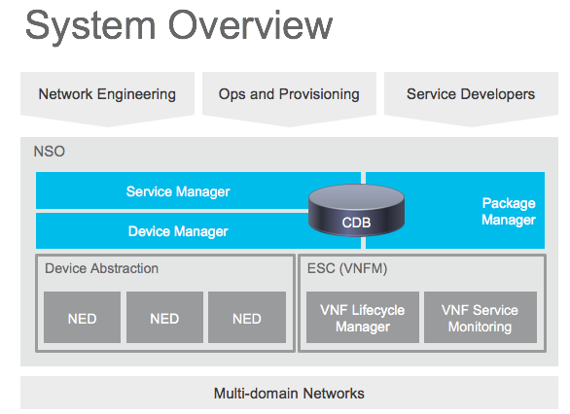

NSO has two main layers:
- Device Manager
- Service Manager
They serve different purposes but are tightly integrated with a transactional engine and database.

The purpose of the Device Manager is to manage device configurations in a transactional manner. It supports features like fine-grained configuration commands, bidirectional device configuration synchronization, device groups and templates, and compliance reporting.

The Service Manager makes it possible for an operator to manage high-level aspects of the network that are not supported by the devices directly or is supported in a cumbersome way. With the appropriate service definition running in the Service Manager, an operator could for example configure the VLANs that should exist in the network in a single place, and the Service Manager compute the specific configuration changes required for each device in the network and push them out. This covers the whole lifecycle for a service: creation, modification and deletion. NSO has an intelligent and easy way to use a mapping layer so that network engineers can define how a service should be deployed in the network.

NSO uses a dedicated built-in storage Configuration Database (CDB) for all configuration data. NSO keeps the CDB in sync with the real network device configurations. Audit, to ensure configuration consistency, and reconciliation, to synchronize configuration with the devices, functions are supported. It also maintains the runtime relationships between service instances and the corresponding device configurations.
NSO uses Network Element Drivers, NEDs, to communicate with devices. NEDs are not closed hard-coded adapters. Rather, the device interface is modeled in a data-model using the YANG data modelling language. NSO can render the required commands or operations directly from this model. This includes support for legacy configuration interfaces like device CLIs. This means that the NEDs can easily be updated to support new commands just by extending the data-models with the appropriate model constructs which avoids any programming tasks as part of the change cycle.

NSO also comes with tooling for simulating the configuration aspects of a network. The netsim tool is used to simulate management interfaces like Cisco CLI and NETCONF for the purpose of examples and service development.

A Service in NSO consists of the following:
- A YANG Service Model: This defines the attributes of the service
- Mapping to the device configuration: When the service is created, corresponding changes must be made to the devices. NSO supports three ways to define this: with templates, with Java, or with Python.

There are two main items to design and implement when designing a new service and the mapping to devices:
- Mapping logic: How service-related operations are reflected on the devices. This involves mapping a service operation to available operations on devices. For example, when you add an access link to a VPN, how is this reflected on Customer Edge and Provider Edge routers?
- Validation logic, while most of the validation can be expressed in the YANG models; there are certain cases where the configuration data validation must be done using external code, for example performing lookups in databases. This step is developed using MAAPI.
NSO stores the service instances and the device configurations in the embedded configuration database (CDB). In contrast to traditional "offline" inventory systems NSO focus on transactional integrity between the database and the network. The core technology of NSO is the capability to read and write configuration to/from the devices. This leads to a "real-time" database that is always in sync with the network. Therefore, NSO can look at the desired device configuration and generate the diff versus current configuration at the model-level. Second, NSO can automatically render the underlying device commands for various interfaces like Cisco-style CLI, NETCONF, and SNMP etc. No programming is required for this. Note that this also includes tricky problems like sending CLI commands or SNMP PDUs in the correct order, depending on what has changed.

The transformation from service models to device models is a complex task and can lead into lots of challenges and problems while dealing with actual configuration details. NSO simplifies this drastically by use of the FASTMAP algorithm. Typically, an engineer defines a higher-level service model representing for example the VPN service itself and this service shall result in actual device configurations. FASTMAP enables automatic management of any kind of change and deletion of a service. All change scenarios and deletions are inferred from a single definition of the creation of the service. The mapping from the service create to the corresponding device configuration is defined in a high-level API or through a template. The programmer only has to define the service create method. If a user changes or deletes an existing service later, NSO calculates the changes.
NSO service mapping is illustrated in below drawing.

Figure 12 : NSO Service Mapping
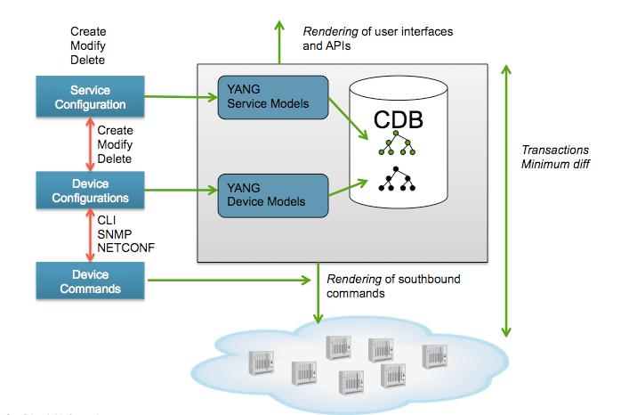

An NSO Service is a function that is provided by the network devices; creating, modifying, deleting the service has effects to the actual configuration of the devices. An NSO service does not include any manual steps; rather it is performed as an ACID transaction towards the network.

A Service Model defines the parameters given to NSO in order to establish the service in the network. NSO collapses the service logic problem to a YANG-to-YANG model transformation. This can be expressed as a device template if the mapping is straightforward and does not include algorithms or calculations, otherwise it can be expressed in a programmatic way using Java or Python.

- The mapping logic reads the service model instance and updates the corresponding device tree.
- The mapping is not aware of any interface specifics like CLI, NETCONF or SNMP. Nor does the mapping take care of southbound errors. This is managed automatically by the transaction manager.
- SCCM Solution Overview
  - Service Configuration and Compliance Manager
Service Configuration and Compliance Manager (SCCM) is a web-based application that acts as a front-end for NSO as well as providing additional workflow management and information caching framework. User creates the order request using SCCM GUI. SCCM then performs validations on the inputs, performs pre-checks and hands over the fully qualified requests to NSO. After NSO completes the job, SCCM performs post-checks using Playbook framework and provides appropriate status to User.

- Service Provisioning request starts with User providing appropriate User Defined (UD) parameters to provision the service to SCCM. Then SCCM with the help of System Defined (SD) parameters, constructs the service.
- SCCM finds the topology based on end point device
- SCCM sends the constructed service request to NSO which updates its database. If the device is not in sync with the NSO then NSO will perform sync operation first and then service is pushed on the devices

Flow A:
- If the service is successfully pushed on the device by NSO then notification is sent to SCCM.
- The post-checks are invoked via Playbook framework.
- Playbook Manager executes the set of commands applicable for the sub service ID and generates pdf service verification report with pass/fail summary along with output of each command.

Flow B:
- If the service is not pushed on 1 device of 5 devices, then NSO will roll back the changes from the routers and response is sent to SCCM
- SCCM would then provide appropriate response to the User

Figure 13 : SCCM Architecture
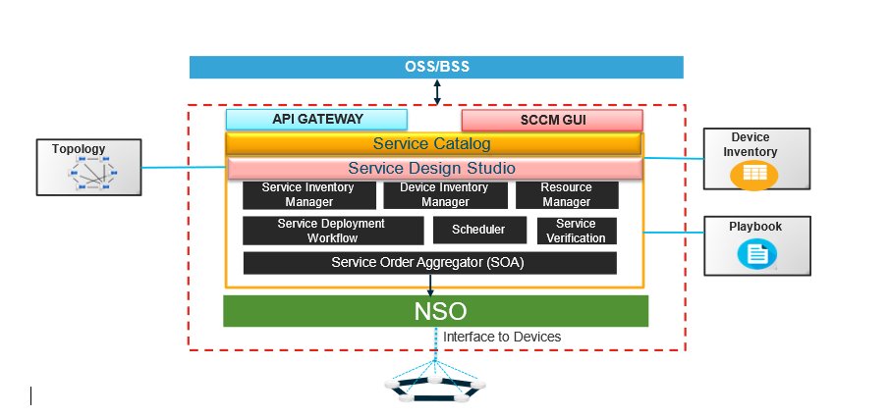

SCCM is also responsible for caching network information and generating reports among other key tasks.
SCCM HA

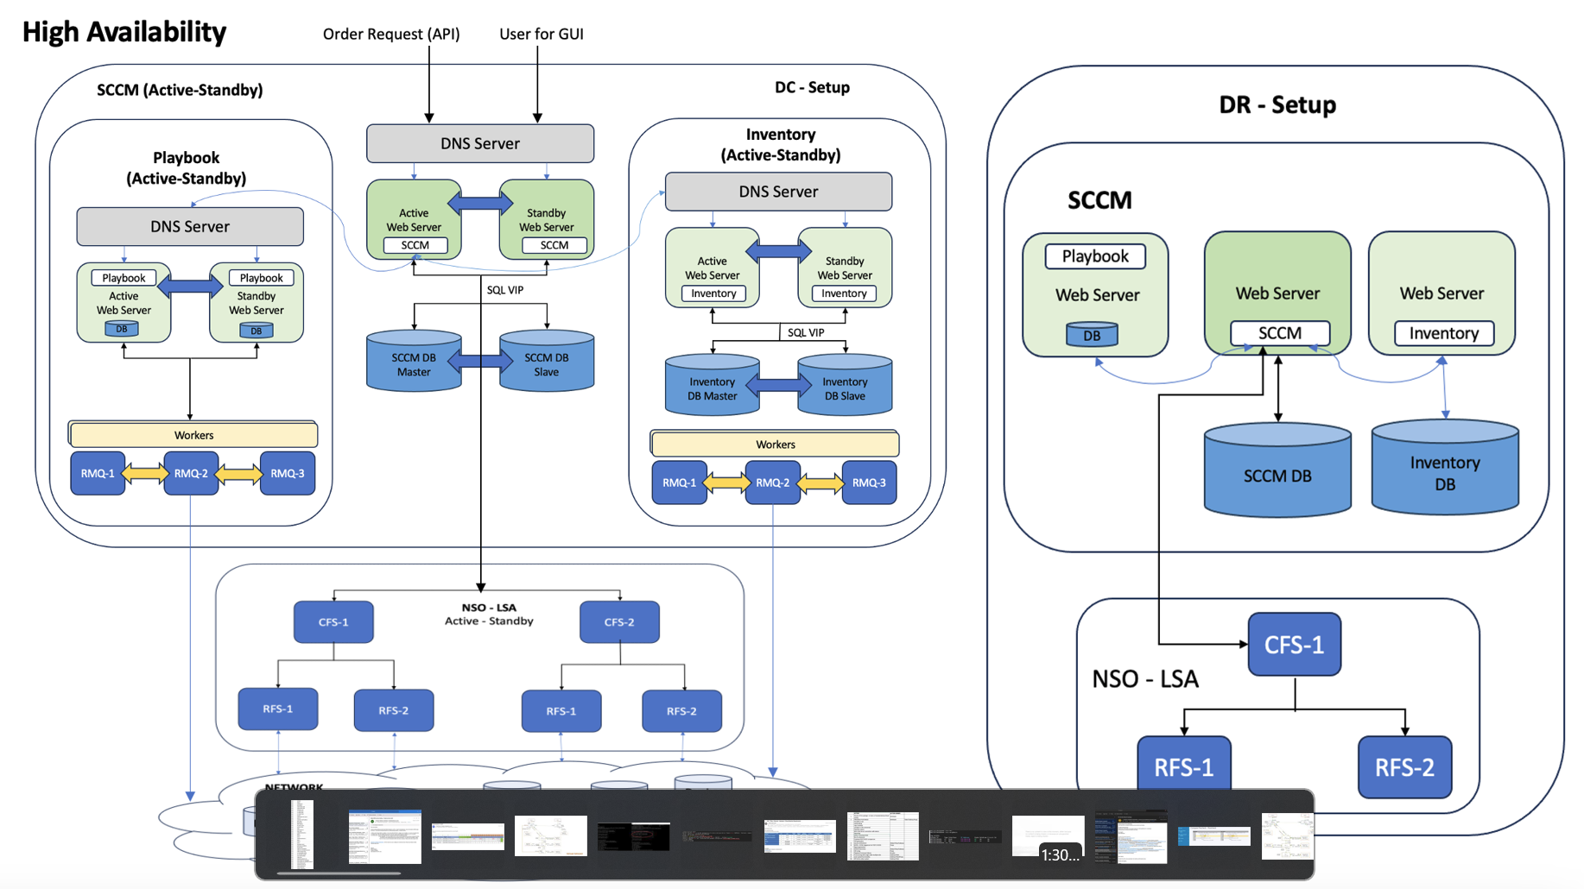

  - Device addition into SCCM – NSO

SCCM provides a feature to end user which enables the user to onboard all devices which are required for service provisioning to SCCM database alongside also adds it to NSO CDB. This gives a flexibility to user to onboard devices directly from SCCM to NSO.

SCCM enables the user to create all other required information required for Onboarding of device. Few Devices related data are “hostname”, “IP Address”, “Port”. Following are few device related information the user can create dynamically before adding a device.

- Device Vendors
- Device Platform
- Device Model
- Device Role
- Device Auth Group
- Device Communication Protocol

Figure 14 : Device addition screen in SCCM & NSO

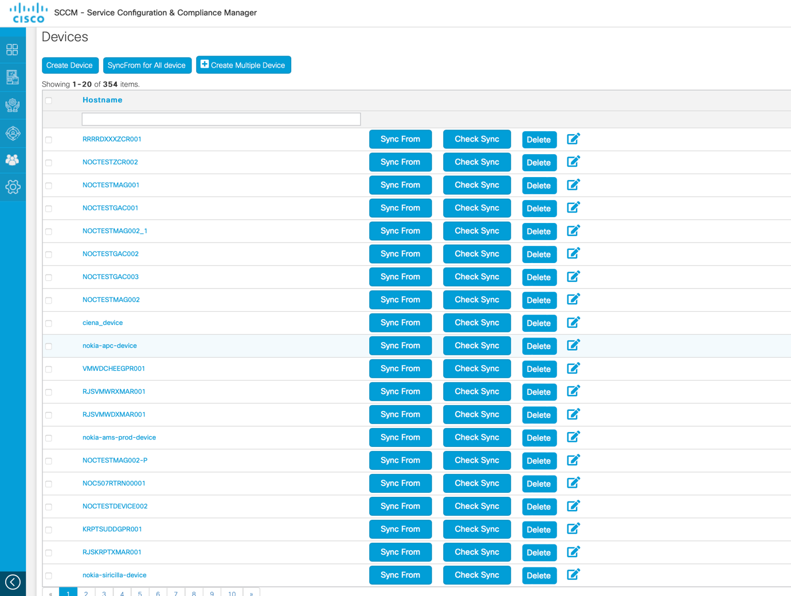

  - System requirements
The following table captures system hardware requirement to deploy the NSO-SCCM servers in production environment

Table 1: System Information NSO-SCCM
 | Descriptions | VM Count | vCPU | RAM (GB) | Storage (GB) | Version
 | Worker (PHP/ Apache) | 2 | 16 | 64 | 300 | 8.0.91/2.4.52
SCCM | RMQ | 3 | 16 | 64 | 300 | 3.9.12
 | Web Server (PHP/ Apache) | 2 | 16 | 64 | 300 | 8.0.91/2.4.52  SCCM – v4.1.1
 | DB (MySQL) | 2 | 16 | 64 | 1500 | 8.0.27
 | Discovery | 1 | 16 | 32 | 300 | v1.0.0
 | Playbook | 1 | 16 | 32 | 300 | v1.1.1
 | Load Balancer (HAProxy) | 2 | 16 | 32 | 300 | version 2.2.9-1build1
NSO | NSO (2 Physical Server) | - | 36 | 256 | 3600 | 5.7

  - Platform Details

Type | Username | Password
CIMC | admin
ESXI | root
VM | root

Following are the host and guest OS details

Host OS (Hyperviser) - VMware ESXi 7.0.3
Guest OS (All VMs) - Ubuntu 20.04
NSO Host OS - RHEL 8.1

- L2VPN/L3VPN Use-Case Service Requirements

This section describes the L2VPN and L3VPN use-case specific service requirements.

  - Device Types
The following device types in the Tfiber network will be configured by SCCM and NSO as part of service provisioning feature.

Table 2: Device type
Device Platform | Role | HW Version
Cisco (Enterprise) | PE | ASR9k
 | PE | ASR 907
 | PE | ASR 920
Nokia | OLT/ONT
Tejas | OLT/ONT
Ciena | DWDM

  - Network reachability
The various components of the NSO-SCCM solution will have reachability to the devices via the in-band network. The SCCM and the NSO server segments will require reachability to the device’s management interface. In the case of switch management, the in-band management interface can be used for device access.

In order to facilitate the above reachability, appropriate rules at the Data Center Firewalls will have to opened and the necessary routing between the domains will have to be established.

The network requirements for SCCM are as below:

System | Server VIP | Active | Standby | Ports
SCCM Web |  | 172.28.2.101 | 172.28.2.112 | 80, 443, 22
SCCM Database IP |  | 172.28.2.102 | 172.28.2.113 | 3306, 22
Playbook Web |  | 172.28.2.108 | 172.28.2.117 | 80, 443, 22
Playbook Database IP |  | 172.28.2.108 |  | 3306,22
Inventory Web |  | 172.28.2.106 | 172.28.2.115 | 80,443,22
Inventory Database IP |  | 172.28.2.107 | 172.28.2.116 | 3306, 22
RabbitMQ |  | 172.28.2.105 | -- | 5672, 15672, 22

The network requirements for NSO are as below:

System | Server VIP | Active | Standby | Ports
NSO | 172.28.2.150 | 172.28.2.109 | 172.28.2.118 | 4569 (CLI), 4570 (HA communication), 8080(Restconf/TCP), 8888(Restconf/SSL), 2022-23, 8102, 4334
 | 172.28.2.133 | 172.28.2.110 | 172.28.2.119
 | 172.28.105.120 | 172.28.2.111 | 172.28.2.120

For the above, the /24 IP pools allocated will be used.

An administrative user will be created in SCCM which will be used to communicate with NSO. If TACACS is the preferred method of authentication, then for the accounts that NSO will use TACACS for authentication will also have to be created manually in SCCM.

  - Service requirements
The following table catalogues the service specific requirements discussed with Tfiber
Table 3: General Requirements
S. No | Requirement | Classification | Status/Comment
1 | Conduct only the service provisioning via SCCM+NSO as per the service flavours identified as per service type’s table. Directly contact the device for service configuration.  Any northbound integration to a portal or Order management system is not included | Required
2 | The SCCM service logic will enforce input validations which are required | Required
3 | Any out of band configuration done by Operations team on the device via CLI or any other means will not be visible to NSO’s service model until explicitly reconciled.  If NSO’s service model and the actual network configuration differs, the dry run generated by NSO during the subsequent MACD operation will not be what is expected and committing will result in inconsistencies | Required
4 | Infrastructure configuration to establish reachability in the MPLS domain will be done by Tfiber | Required
5 | NED’s will be provided by the BU and will be procured by the customer | Required
  - Service Catalogue
The following table lists the service catalogue that will be referenced for the configuration of the services.
    - L2VPN Enterprise Service Catalogues

Sr.No | Product | Device Type | Service Type | Routing Protocol | Termination | Technology | Managed
1 | L2VPN | Cisco | Enterprise VPN | N/A | ASR920/ASR907/ASR9K | VPLS | Yes
2 | L2VPN | Nokia | Enterprise VPN | N/A | ASR920/ASR907/ASR9K | VPLS | Yes
3 | L2VPN | Tejas | Enterprise VPN | N/A | ASR920/ASR907/ASR9K | VPLS | Yes
4 | L2VPN | Nokia | HSI | N/A | ASR920/ASR907 | VPLS | Yes
5 | L2VPN | Tejas | HSI | N/A | ASR920/ASR907 | VPLS | Yes
6 | L2VPN | Nokia | VOIP | N/A | ASR920/ASR907 | VPLS | Yes
7 | L2VPN | Tejas | VOIP | N/A | ASR920/ASR907 | VPLS | Yes
8 | L2VPN | Nokia | IPTV | N/A | ASR920/ASR907 | VPLS | Yes
9 | L2VPN | Tejas | IPTV | N/A | ASR920/ASR907 | VPLS | Yes
10 | L2VPN | Nokia | TCELL | N/A | ASR920/ASR907 | VPLS | Yes
11 | L2VPN | Tejas | TCELL | N/A | ASR920/ASR907 | VPLS | Yes

    - L3VPN Enterprise Service Catalogues

Sr. No. | Product | Device Type | Service type | Routing Protocol | Termination | Technology | Managed
1 | L3VPN | Cisco | Enterprise VPN Single last mile | BGP/OSPF/Static | ASR920/ASR907/ASR9K | MPLSVPN & VPLS | Yes
2 | L3VPN | Nokia | Enterprise VPN | N/A | ASR920/ASR907 | MPLSVPN & VPLS | Yes
3 | L3VPN | Tejas | Enterprise VPN | N/A | ASR920/ASR907 | MPLSVPN & VPLS | Yes
4 | L3VPN | Nokia | GI-BB | N/A | ASR920/ASR907 | MPLSVPN | Yes
5 | L3VPN | Tejas | GI-BB | N/A | ASR920/ASR907 | MPLSVPN | Yes
6 | L3VPN | Cisco | Enterprise VPN Dual last mile | BGP/OSPF/Static | ASR920/ASR907/ASR9K | MPLSVPN & VPLS | Yes

Note – For new/create order, Number of leg will remain 1 via SCCM/NSO. It will be full mesh connectivity for multiple branches of customer.

  - Service Input Variables
The following table lists the service input variables required for the configuration of the services.

    - Nokia Service Input Variable (User / System Defined)

Variable Name | SD | UD
service-id | Y | N
circuit-id | Y | N
olt-pon-port | N | Y
device-name | Y | N
nokia-ams-template | Y | N
nokia-ams-template-version | Y | N
ont-serial-number | N | Y
service-id | Y | N
ds-bandwith-profile | N | Y
us-bandwidth-profile | N | Y
network-vlan-name | Y | N

US/SD – Variables are derived by the system and user has flexibility to change the input from the derived multiple values however providing manual input will not be allowed.

    - Tejas Service Input Variable (User / System Defined)

Variable Name | SD | UD
device-name | Y | N
service-order-id | Y | N
circuit-id | Y | N
connectivity-service-uuid | Y | N
end-point-uuid | Y | N
ingress-operation | Y | N
internet-vlan | Y | N
ont-eth-port-instance | Y | N
ont-serial-number | N | Y
tejas-vlan | Y | N
untagged-and-prio-tagged-included | Y | N
upstream-bandwdth-profile-uuid | Y | N
vlan-id-mapping-type | Y | N
cos-name | Y | N

Cisco (L2VPN) Service Input Variable (User / System Defined)

Variable Name | SD | UD
circuit-id | Y | N
site-id | Y | N
device-mode | Y | N
device-name | Y | N
ip-type | Y | N
mtu | Y | N
sub-interface-id | Y | N
interfaceID | Y | N
transaction-id | Y | N
bridge-group | Y | N
pw-class | Y | N
vfi-name | Y | N
internet-vlan | Y | N
ipv4 | Y | N
nei-ag2-ip | Y | N
pw-id | Y | N
vpn-id | Y | N
nei-ag2-ip2-dual | Y | N
nei-ag2-vcid | Y | N

Cisco (L3VPN) PE-CE Protocol Service Input Variable

Variable Name | SD | UD
cust-pref-name-ipv4 | Y | N
cust-pref-name-ipv6 | Y | N
device-mode | Y | N
device-name | Y | N
route-name-ipv4 | Y | N
route-name-ipv6 | Y | N
transaction-id | Y | N
bgp-id | Y | N
minimum-interval | Y | N
multiplier | Y | N
ospf-process-id | Y | N
rd | Y | N
router-id | Y | N
VRF-name | Y | N
circuit-id | Y | N
pe-type | Y | N
routing-protocol | Y | N
site-id | Y | N
topology-name | Y | N
vpn-id | Y | N
route-policy-name | Y | N
ip-type-ipv4 | Y | N
ipv4-pool-xr-prefix-set | Y | N
address-family | Y | N
rt-export | Y | N
rt-import | Y | N
interfaceID | Y | N
internet-vlan | Y | N
ip-type | Y | N
ipv4-address | Y | N
mtu-load-required | Y | N
customer-lan-pool-ipv6 | Y | N
provider-as-no | Y | N
redistribute-connected-required | Y | N
router-static-required | Y | N
BDI | Y | N
ipv4-wan-address | Y | N
ospf-area-id | Y | N
ospf-network | Y | N
ospf-subnet | Y | N
sequence | Y | N
ipv4-pool | Y | N
name | Y | N
seq-no | Y | N
route-name-lp-ipv4 | Y | N
local-preference | Y | N
bfd-required | N | Y
bgp-customer-ipv4-address | Y | N
cust-as-no | Y | N
import-path-required | Y | N
Route-MAP | Y | N
remote-as-no | Y | Y
redistribute-static-required | Y | N
vlan-facing-cust | Y | N
ipv4 | Y | N
nei-ag2-ip | Y | N
pw-id | Y | N
vfi-name | Y | N
child-policy-map-inward | Y | N
child-policy-map-outward | Y | N
policy-map-uni-inward | Y | N
policy-map-uni-outward | Y | N
qos-name | Y | Y

- Cisco Solution
  - SCCM-NSO Solution Deployment Methodology

Figure 15 : SCCM-NSO solution Deployment Methodology
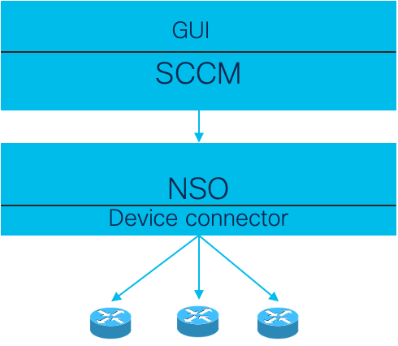

- The Orchestration solution will be deployed with Middleware- SCCM
- SCCM communicates with NSO in the southbound
- NSO receive request from SCCM in northbound and push the config in southbound
- Devices are onboarded into NSO for service provisioning

  - Solution Provisioning Flow

Figure 16 : Service Provisioning Flow
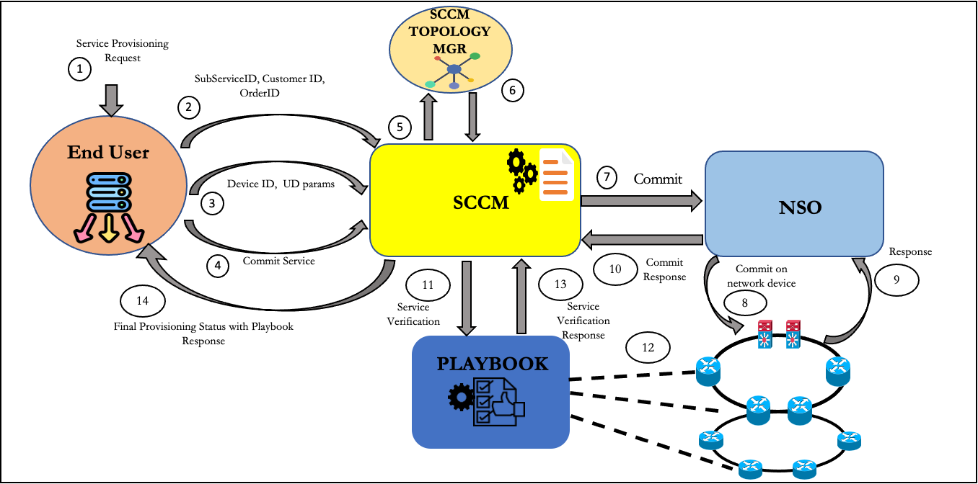

- The process starts user logging into SCCM system
- A set of pre-checks that are executed in SCCM using the devices involved in the operation.
- Once the prechecks pass, a configuration preview is generated which the user may view. After the user approves, the order (or the orders in the queue) is handed over to NSO. NSO in turn executes the configuration changes and applies all the configuration changes to the devices and returns.
- If at this stage if NSO is unable to commit the order due to discrepancies such as devices being out of sync with the CDB or in case of a deviation of network parameters from those in the order, the order is flagged and held, while remediation of the above faults takes place.
- After the configuration is committed, the post-checks are invoked via Playbook framework. If the post-checks fail, SCCM would revert any configuration changes made by NSO and fail the order.
- The final status is communicated by SCCM to the user.

  - API flow between SCCM and NSO
Below diagram shows interaction between SCCM and NSO for a particular order that is placed by end user on SCCM GUI.

Figure 17 : SCCM-NSO API Sequence diagram
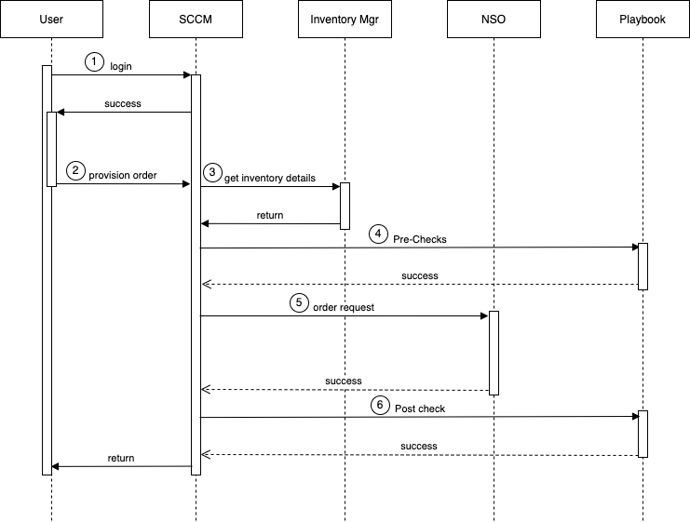

  - NSO Service Package structure and details
NSO service package provides functionality to translate parameters sent by northbound system to device specific configuration and applies to network using NED (Network Element Driver).

The service package consists of service model (defined in Yang file), service template (XML representation of device configs) and Java or Python code to map the parameters, if required.
The Yang model file captures service parameters that are sent from northbound system (SCCM) and these are used in service template XML files to apply the configuration to the network devices.

The L2VPN service packages are structured as parent and child packages. The parent package invokes child package during execution. The details of the package are as below:
- common: These define common elements of services
- l2vpn-mpls: The parent (top level) service package that defines the L2VPN service parameters that SCCM would send to NSO as per structure defined in the model
- interface: The child (low level) service package that defines all interface related parameters and corresponding template files for Cisco device platform
- mpls-l2vpn: The child service package that defines l2vpn config parameters and templates for Cisco device
- l3vpn-mpls: The parent service package that defines the L3VPN service parameters that SCCM would send to NSO as per structure defined in the model for Cisco

The Yang tree representation of the packages below shows the model parameter names and respective datatype:

The service package directory structure of the above mentioned packages in repository:
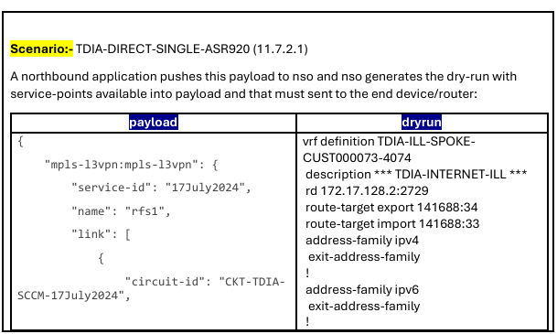

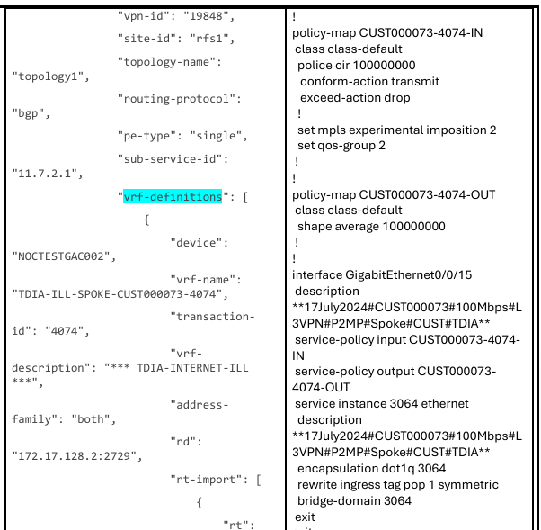
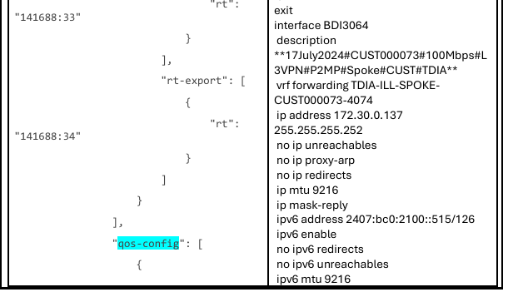
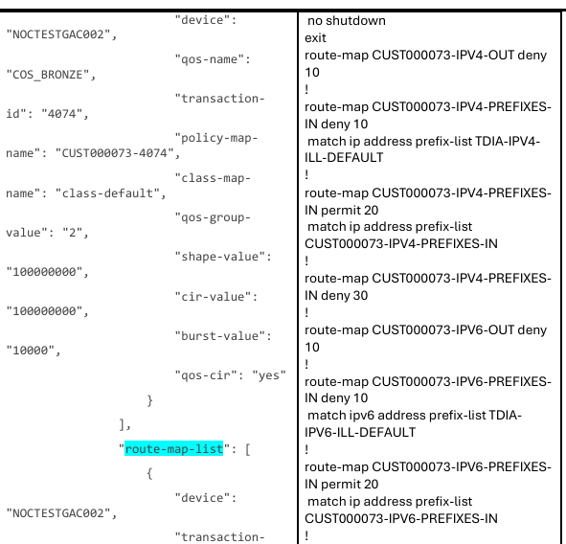
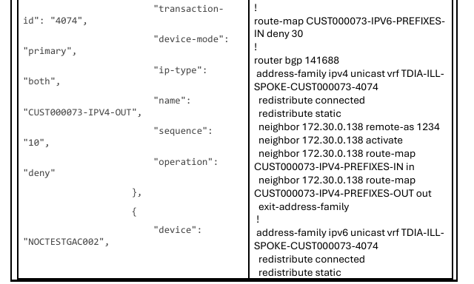
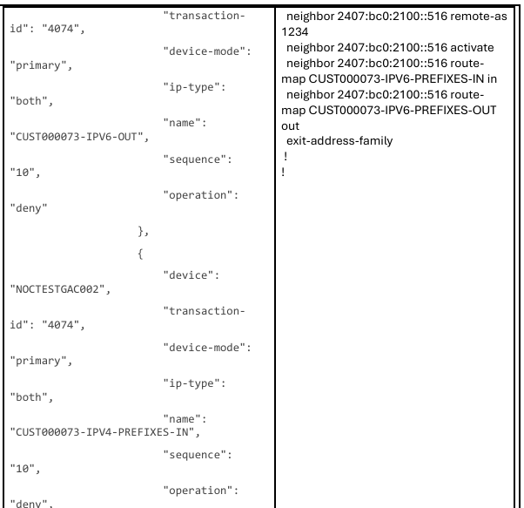
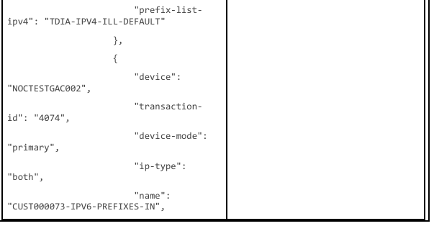
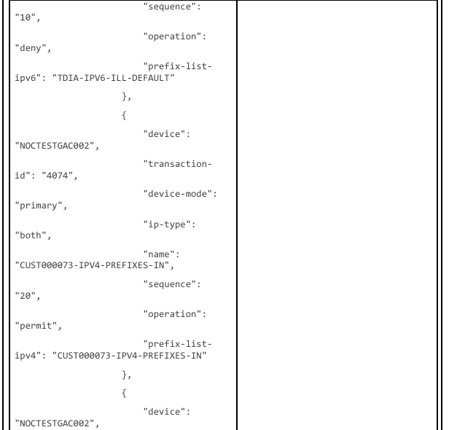
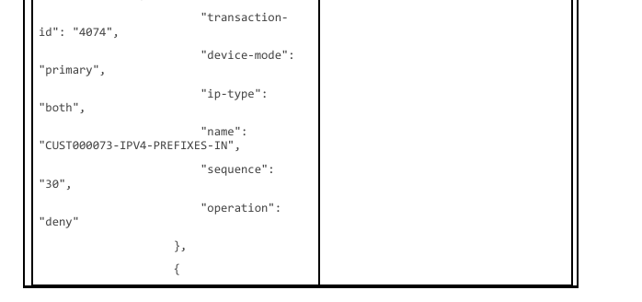
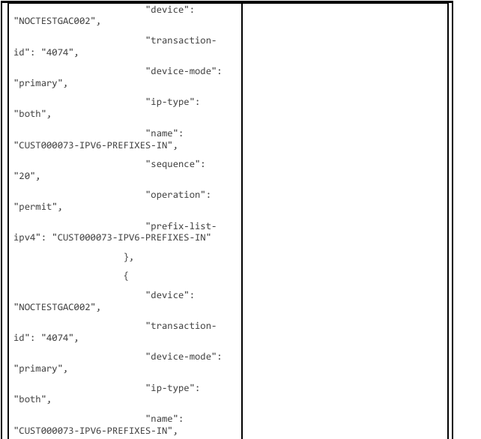
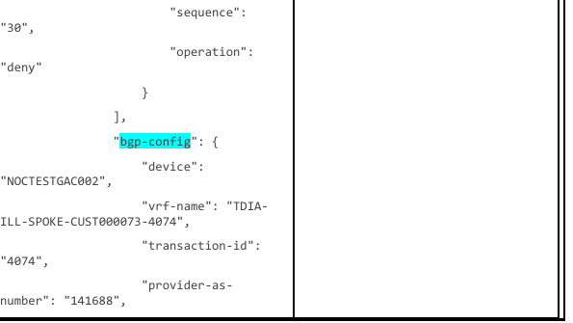
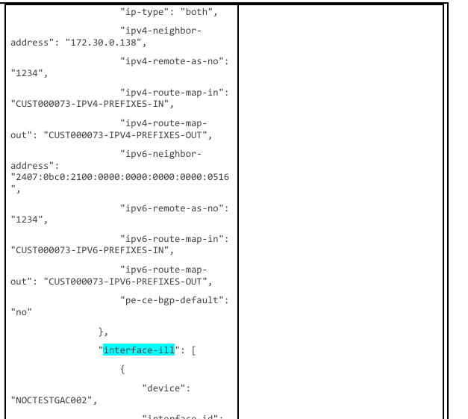
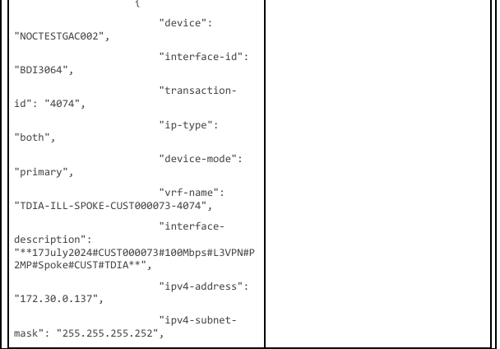
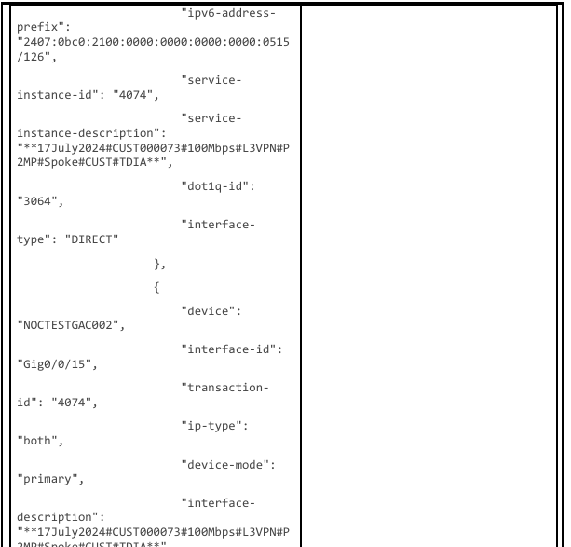
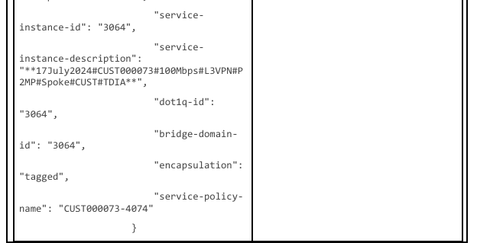

For this service config below service point has been used:
• mpls-l3vpn, as a parent service • vrf-definitions
• qos-config • route-map-list
• bgp-config • interface-ill
• vrf-definitions:
For vrf-definitions service point parent-packages-service(mpls-l3vpn) using the below service package of NSO: /var/opt/ncs/packages/vrf/
• qos-config:
For qos-config service point parent-packages-service(mpls-l3vpn) using the below service package of NSO: /var/opt/ncs/packages/qos/
• route-map-list: For route-map-list service point, parent-packages-service(mpls-l3vpn) using the below service package of NSO: /var/opt/ncs/packages/route-map/
• bgp-config: For bgp-config service point, parent-packages-service(mpls-l3vpn) using the below service package of NSO: /var/opt/ncs/packages/bgp/
• interface-ill: For interface-ill service point, parent-packages-service(mpls-l3vpn) using the below service package of NSO: /var/opt/ncs/packages/ interface-ill/
#Each service package having src & templates directory structure that contains yang and xml file. For example, taking “/var/opt/ncs/packages/bgp/” package: • yang file path: /var/opt/ncs/packages/bgp/src/yang/ bgp.yang • xml file path: /var/opt/ncs/packages/bgp/templates/ bgp template.xml

A sample service package directory structure of the CFS & RFS packages in repository:

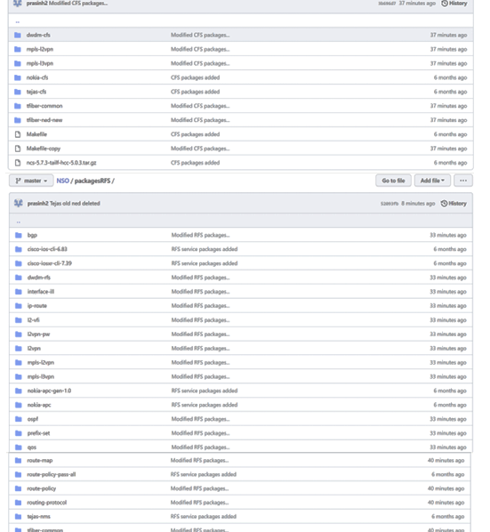

- l3vpn:
module: mpls-l3vpn
+--rw l3vpn* [service-id]
+---x check-sync
| +---w input
| | +---w outformat? outformat4
| | +---w (depth)?
| | | +--:(deep)
| | | | +---w deep? empty
| | | +--:(shallow)
| | | +---w shallow? empty
| | +---w suppress-positive-result? empty
| | +---w (choice-lsa)?
| | +--:(use-lsa)
| | | +---w use-lsa? empty
| | +--:(no-lsa)
| | +---w no-lsa? empty
| +--ro output
| +--ro (outformat)?
| +--:(in-sync)
| | +--ro in-sync? boolean
| +--:(case-xml)
| | +--ro result-xml
| | +--ro local-node
| | | +--ro data? <anyxml>
| | +--ro lsa-node* []
| | +--ro name? string
| | +--ro data? <anyxml>
| +--:(case-cli)
| | +--ro cli
| | +--ro local-node
| | | +--ro data? string
| | +--ro lsa-node* []
| | +--ro name? string
| | +--ro data? string
| +--:(case-cli-c)
| | +--ro cli-c
| | +--ro local-node
| | | +--ro data? string
| | +--ro lsa-node* []
| | +--ro name? string
| | +--ro data? string
| +--:(case-native)
| +--ro native
| +--ro device* [name]
| +--ro name string
| +--ro data? string
+---x deep-check-sync
| +---w input
| | +---w outformat? outformat-deep-check-sync
| | +---w suppress-positive-result? empty
| | +---w (choice-lsa)?
| | | +--:(use-lsa)
| | | | +---w use-lsa? empty
| | | +--:(no-lsa)
| | | +---w no-lsa? empty
| | +---w (wait-for-lock-choice)?
| | +--:(no-wait-for-lock)
| | | +---w no-wait-for-lock? empty
| | +--:(wait-for-lock)
| | +---w wait-for-lock!
| | +---w (timeout-choice)?
| | +--:(timeout)
| | | +---w timeout? uint32
| | +--:(infinity)
| | +---w infinity? empty
| +--ro output
| +--ro (outformat)?
| +--:(case-xml)
| | +--ro result-xml
| | +--ro local-node
| | | +--ro data? <anyxml>
| | +--ro lsa-service* [service-id]
| | +--ro service-id instance-identifier
| | +--ro data? <anyxml>
| +--:(case-cli)
| | +--ro cli
| | +--ro local-node
| | | +--ro data? string
| | +--ro lsa-service* [service-id]
| | +--ro service-id instance-identifier
| | +--ro data? string
| +--:(case-cli-c)
| | +--ro cli-c
| | +--ro local-node
| | | +--ro data? string
| | +--ro lsa-service* [service-id]
| | +--ro service-id instance-identifier
| | +--ro data? string
| +--:(case-sync)
| +--ro sync-result
| +--ro local-node
| | +--ro in-sync? boolean
| +--ro lsa-service* [service-id]
| +--ro service-id instance-identifier
| +--ro in-sync? boolean
+---x re-deploy
| +---w input
| | +---w dry-run!
| | | +---w outformat? outformat3
| | +---w no-revision-drop? empty
| | +---w no-networking? empty
| | +---w (choice-sync-check)?
| | | +--:(no-overwrite)
| | | | +---w no-overwrite? empty
| | | +--:(no-out-of-sync-check)
| | | +---w no-out-of-sync-check? empty
| | +---w commit-queue!
| | | +---w tag? string
| | | +---w (operation-mode)?
| | | | +--:(async)
| | | | | +---w async? empty
| | | | +--:(sync)
| | | | | +---w sync!
| | | | | +---w (timeout-choice)?
| | | | | +--:(timeout)
| | | | | | +---w timeout? uint32
| | | | | +--:(infinity)
| | | | | +---w infinity? empty
| | | | +--:(bypass)
| | | | +---w bypass? empty
| | | +---w block-others? empty
| | | +---w lock? empty
| | | +---w atomic? boolean
| | | +---w error-option? enumeration
| | | +---w unlock!
| | | +---w (choice-unlock-id)?
| | | +--:(id)
| | | | +---w id? uint64
| | | +--:(tag)
| | | +---w tag? string
| | +---w (choice-lsa)?
| | | +--:(use-lsa)
| | | | +---w use-lsa? empty
| | | +--:(no-lsa)
| | | +---w no-lsa? empty
| | +---w wait-device* -> /ncs:devices/device/name
| | +---w trace-id? string
| | +---w (depth)?
| | | +--:(deep)
| | | | +---w deep? empty
| | | +--:(shallow)
| | | +---w shallow? empty
| | +---w reconcile!
| | +---w (c-non-service-config)?
| | +--:(keep-non-service-config)
| | | +---w keep-non-service-config? empty
| | +--:(discard-non-service-config)
| | +---w discard-non-service-config? empty
| +--ro output
| +--ro (outformat)?
| | +--:(case-xml)
| | | +--ro result-xml
| | | +--ro local-node
| | | | +--ro data? <anyxml>
| | | +--ro lsa-node* []
| | | +--ro name? string
| | | +--ro data? <anyxml>
| | +--:(case-cli)
| | | +--ro cli
| | | +--ro local-node
| | | | +--ro data? string
| | | +--ro lsa-node* []
| | | +--ro name? string
| | | +--ro data? string
| | +--:(case-cli-c)
| | | +--ro cli-c
| | | +--ro local-node
| | | | +--ro data? string
| | | +--ro lsa-node* []
| | | +--ro name? string
| | | +--ro data? string
| | +--:(case-native)
| | +--ro native
| | +--ro device* [name]
| | +--ro name string
| | +--ro data? string
| +--ro commit-queue
| +--ro id? -> /ncs:devices/commit-queue/queue-item/id
| +--ro status? enumeration
| +--ro failed-device* [name]
| +--ro name -> /ncs:devices/device/name
| +--ro reason? string
+---x reactive-re-deploy
| +---w input
| | +---w sync? empty
| +--ro output
| +--ro commit-queue
| +--ro id? -> /ncs:devices/commit-queue/queue-item/id
| +--ro status? enumeration
| +--ro failed-device* [name]
| +--ro name -> /ncs:devices/device/name
| +--ro reason? string
+---x touch
+--ro modified
| +--ro devices* -> /ncs:devices/device/name
| +--ro services* instance-identifier
| +--ro lsa-services* instance-identifier
+--ro directly-modified
| +--ro devices* -> /ncs:devices/device/name
| +--ro services* instance-identifier
| +--ro lsa-services* instance-identifier
+---x get-modifications
| +---w input
| | +---w outformat? outformat2
| | +---w reverse? empty
| | +---w (depth)?
| | | +--:(deep)
| | | | +---w deep? empty
| | | +--:(shallow)
| | | +---w shallow? empty
| | +---w (choice-lsa)?
| | +--:(use-lsa)
| | | +---w use-lsa? empty
| | +--:(no-lsa)
| | +---w no-lsa? empty
| +--ro output
| +--ro (outformat)?
| +--:(case-xml)
| | +--ro result-xml
| | +--ro local-node
| | | +--ro data? <anyxml>
| | +--ro lsa-service* [service-id]
| | +--ro service-id instance-identifier
| | +--ro data? <anyxml>
| +--:(case-cli)
| | +--ro cli
| | +--ro local-node
| | | +--ro data? string
| | +--ro lsa-service* [service-id]
| | +--ro service-id instance-identifier
| | +--ro data? string
| +--:(case-cli-c)
| +--ro cli-c
| +--ro local-node
| | +--ro data? string
| +--ro lsa-service* [service-id]
| +--ro service-id instance-identifier
| +--ro data? string
+---x un-deploy
| +---w input
| | +---w dry-run!
| | | +---w outformat? outformat3
| | +---w no-revision-drop? empty
| | +---w no-networking? empty
| | +---w (choice-sync-check)?
| | | +--:(no-overwrite)
| | | | +---w no-overwrite? empty
| | | +--:(no-out-of-sync-check)
| | | +---w no-out-of-sync-check? empty
| | +---w commit-queue!
| | | +---w tag? string
| | | +---w (operation-mode)?
| | | | +--:(async)
| | | | | +---w async? empty
| | | | +--:(sync)
| | | | | +---w sync!
| | | | | +---w (timeout-choice)?
| | | | | +--:(timeout)
| | | | | | +---w timeout? uint32
| | | | | +--:(infinity)
| | | | | +---w infinity? empty
| | | | +--:(bypass)
| | | | +---w bypass? empty
| | | +---w block-others? empty
| | | +---w lock? empty
| | | +---w atomic? boolean
| | | +---w error-option? enumeration
| | | +---w unlock!
| | | +---w (choice-unlock-id)?
| | | +--:(id)
| | | | +---w id? uint64
| | | +--:(tag)
| | | +---w tag? string
| | +---w (choice-lsa)?
| | | +--:(use-lsa)
| | | | +---w use-lsa? empty
| | | +--:(no-lsa)
| | | +---w no-lsa? empty
| | +---w wait-device* -> /ncs:devices/device/name
| | +---w trace-id? string
| | +---w ignore-refcount? empty
| +--ro output
| +--ro (outformat)?
| | +--:(case-xml)
| | | +--ro result-xml
| | | +--ro local-node
| | | | +--ro data? <anyxml>
| | | +--ro lsa-node* []
| | | +--ro name? string
| | | +--ro data? <anyxml>
| | +--:(case-cli)
| | | +--ro cli
| | | +--ro local-node
| | | | +--ro data? string
| | | +--ro lsa-node* []
| | | +--ro name? string
| | | +--ro data? string
| | +--:(case-cli-c)
| | | +--ro cli-c
| | | +--ro local-node
| | | | +--ro data? string
| | | +--ro lsa-node* []
| | | +--ro name? string
| | | +--ro data? string
| | +--:(case-native)
| | +--ro native
| | +--ro device* [name]
| | +--ro name string
| | +--ro data? string
| +--ro commit-queue
| +--ro id? -> /ncs:devices/commit-queue/queue-item/id
| +--ro status? enumeration
| +--ro failed-device* [name]
| +--ro name -> /ncs:devices/device/name
| +--ro reason? string
+--ro used-by-customer-service* -> /ncs:services/customer-service/object-id
+--ro commit-queue
| +---x clear
| +--ro queue-item* [id]
| +--ro id uint64
| +--ro status? enumeration
| +--ro cleared-by-admin? empty
| +--ro failed-device* [name]
| | +--ro name -> /ncs:devices/device/name
| | +--ro time? yang:date-and-time
| | +--ro config-data? string
| | +--ro error? string
| +---x admin-clear
| +---x delete
+--rw private
| +--rw diff-set? binary
| +--rw forward-diff-set? binary
| +--rw device-list* string
| +--rw ned-id-list* string
| +--rw service-list* instance-identifier
| +--rw lsa-service-list* yang:xpath1.0
| +--rw synthesizer-kicker-list* instance-identifier
| +--rw property-list
| | +--rw property* [name]
| | +--rw name string
| | +--rw value? string
| +--rw re-deploy-counter? int32
| +--rw latest-commit-params? binary
| +--rw latest-u-info? binary
+--ro plan-location? instance-identifier
+--ro log
| +---x purge
| | +---w input
| | | +---w type? log-entry-t
| | | +---w level? log-entry-level-t
| | | +---w older-than!
| | | +---w (age-spec)?
| | | +--:(seconds)
| | | | +---w seconds? uint16
| | | +--:(minutes)
| | | | +---w minutes? uint16
| | | +--:(hours)
| | | | +---w hours? uint16
| | | +--:(days)
| | | | +---w days? uint16
| | | +--:(weeks)
| | | +---w weeks? uint16
| | +--ro output
| | +--ro purged-log-entries? uint16
| +--ro log-entry* [when]
| +--ro when yang:date-and-time
| +--ro type log-entry-t
| +--ro level log-entry-level-t
| +--ro message? string
+--rw service-id string
+--rw link* [circuit-id]
+--rw circuit-id common:non-empty-string
+--rw sub-service-id string
+--rw vpn-id? uint64
+--rw site-id? common:non-empty-string
+--rw topology-name? string
+--rw managed? common:managed-type
+--rw routing-protocol common:routing-protocols
+--rw termination-device? common:non-empty-string
+--rw is-mds? enumeration
+--rw is-eds? enumeration
+--rw pe-type common:pe-types
+--rw interface* [interface-id connected-device transaction-id]
| +--rw interface-id string
| +--rw connected-device -> /ncs:devices/device/name
| +--rw transaction-id string
| +--rw device-mode? enumeration
| +--rw ip-type enumeration
| +--rw dual-homed? string
| +--rw bfd-required? common:bfd-required
| +--rw mtu-load-required? common:bfd-required
| +--rw interface-type? string
| +--rw trunk-no? uint32
| +--rw customer-vlan* [vlan-id]
| | +--rw vlan-id uint32
| +--rw ipv4-address? string
| +--rw ipv6-address? string
| +--rw ipv4-access-group? string
| +--rw ipv6-access-group? string
| +--rw outer-vlan? string
| +--rw mtu? uint32
| +--rw bundle-id? uint32
| +--rw desc? string
| +--rw vrf-name? string
| +--rw ipv4-wan-address? string
| +--rw ipv6-wan-address? string
| +--rw vrrp-configs
| | +--rw group-no? uint32
| | +--rw vip-ipv4? inet:ip-address
| | +--rw ipv6-address1? inet:ip-address
| | +--rw ipv6-address2? string
| +--rw service-instance-no* [inst-no]
| | +--rw inst-no uint32
| | +--rw raps-vlan? uint32
| | +--rw nei-ip? string
| | +--rw vpn-id? uint32
| +--rw service-policy-name? string
+--rw phwe* [ag2-device transaction-id]
| +--rw ag2-device -> /ncs:devices/device/name
| +--rw transaction-id string
| +--rw ip-type common:non-empty-string
| +--rw bvi-config* [bvi-no]
| | +--rw bvi-no uint32
| | +--rw vrf-name? string
| | +--rw bvi-ip-addr? inet:ip-address
| +--rw routing-protocol
| +--rw ce-intf-ip? string
| +--rw cust-lan-pool? string
+--rw l2vpn* [name device bri-dom-name]
| +--rw name string
| +--rw device -> /ncs:devices/device/name
| +--rw bri-dom-name string
| +--rw pw-class? string
| +--rw bri-grp-name? string
| +--rw neighbor* [ip]
| | +--rw ip string
| | +--rw vpn-id? uint64
| +--rw cust-vlan? string
| +--rw ecr-nei-ip? string
| +--rw vfi_name? string
| +--rw interface-list* [interface-id]
| +--rw routed-interface-list* [interface-id]
+--rw bgp* [device bgp-id provider-as-no transaction-id]
| +--rw device -> /ncs:devices/device/name
+--rw static* [device bgp-id provider-as-no transaction-id]
| +--rw device -> /ncs:devices/device/name
+--rw qos
+--rw ag1-l2-ext* [device-name vrf-name transaction-id]
| +--rw device-name -> /ncs:devices/device/name
| +--rw vrf-name string
| +--rw transaction-id string
| +--rw vpn-id? int32
| +--rw address-list* [nei-ip]
| +--rw nei-ip inet:ipv4-address
+--rw demarc* [device customer-vlan-1]
+--rw erps-config* [device ring-no transaction-id]
+--rw qos-config* [device qos-name transaction-id]
| +--rw device -> /ncs:devices/device/name
| +--rw qos-name common:qos-type
| +--rw transaction-id string
+--rw l3vpn-static-xr* [vrf-name]
| +--rw vrf-name string
| +--rw cust-lan-pool? string
| +--rw bvi-nei-address-family? string
| +--rw bvi-nei-ip? inet:ip-address
| +--rw rd? string
+--rw prefix-set-list* [device name transaction-id]
+--rw route-map-list* [device name transaction-id]
+--rw route-policy-list* [device name transaction-id]
+--rw ospf* [device vrf-name transaction-id]
+--rw route-policy-pass-all* [route-policy-name device-name transaction-id]
| +--rw route-policy-name string
| +--rw device-name -> /ncs:devices/device/name
| +--rw transaction-id string
| +--rw value? string
+--rw l2-vfi* [vrf-name device-name transaction-id]
| +--rw vrf-name string
| +--rw device-name -> /ncs:devices/device/name
| +--rw transaction-id string
| +--rw vpn-id? uint32
| +--rw vlan-cust? uint32
| +--rw nei-ag2-ip? inet:ipv4-address
| +--rw nei-ag2-ip2? inet:ipv4-address
| +--rw no-split-horizon? enumeration
| +--rw no-split-horizon2? enumeration
| +--rw nei-ag2-vcid? string
| +--rw nei-ag2-vcid2? string
+--rw vrf-definitions* [device vrf-name transaction-id]

- l2vpn:
module: l2vpn
+--rw l2vpn* [name device bri-dom-name]
+---x check-sync
| +---w input
| | +---w outformat? outformat4
| | +---w (depth)?
| | | +--:(deep)
| | | | +---w deep? empty
| | | +--:(shallow)
| | | +---w shallow? empty
| | +---w suppress-positive-result? empty
| | +---w (choice-lsa)?
| | +--:(use-lsa)
| | | +---w use-lsa? empty
| | +--:(no-lsa)
| | +---w no-lsa? empty
| +--ro output
| +--ro (outformat)?
| +--:(in-sync)
| | +--ro in-sync? boolean
| +--:(case-xml)
| | +--ro result-xml
| | +--ro local-node
| | | +--ro data? <anyxml>
| | +--ro lsa-node* []
| | +--ro name? string
| | +--ro data? <anyxml>
| +--:(case-cli)
| | +--ro cli
| | +--ro local-node
| | | +--ro data? string
| | +--ro lsa-node* []
| | +--ro name? string
| | +--ro data? string
| +--:(case-cli-c)
| | +--ro cli-c
| | +--ro local-node
| | | +--ro data? string
| | +--ro lsa-node* []
| | +--ro name? string
| | +--ro data? string
| +--:(case-native)
| +--ro native
| +--ro device* [name]
| +--ro name string
| +--ro data? string
+---x deep-check-sync
| +---w input
| | +---w outformat? outformat-deep-check-sync
| | +---w suppress-positive-result? empty
| | +---w (choice-lsa)?
| | | +--:(use-lsa)
| | | | +---w use-lsa? empty
| | | +--:(no-lsa)
| | | +---w no-lsa? empty
| | +---w (wait-for-lock-choice)?
| | +--:(no-wait-for-lock)
| | | +---w no-wait-for-lock? empty
| | +--:(wait-for-lock)
| | +---w wait-for-lock!
| | +---w (timeout-choice)?
| | +--:(timeout)
| | | +---w timeout? uint32
| | +--:(infinity)
| | +---w infinity? empty
| +--ro output
| +--ro (outformat)?
| +--:(case-xml)
| | +--ro result-xml
| | +--ro local-node
| | | +--ro data? <anyxml>
| | +--ro lsa-service* [service-id]
| | +--ro service-id instance-identifier
| | +--ro data? <anyxml>
| +--:(case-cli)
| | +--ro cli
| | +--ro local-node
| | | +--ro data? string
| | +--ro lsa-service* [service-id]
| | +--ro service-id instance-identifier
| | +--ro data? string
| +--:(case-cli-c)
| | +--ro cli-c
| | +--ro local-node
| | | +--ro data? string
| | +--ro lsa-service* [service-id]
| | +--ro service-id instance-identifier
| | +--ro data? string
| +--:(case-sync)
| +--ro sync-result
| +--ro local-node
| | +--ro in-sync? boolean
| +--ro lsa-service* [service-id]
| +--ro service-id instance-identifier
| +--ro in-sync? boolean
+---x re-deploy
| +---w input
| | +---w dry-run!
| | | +---w outformat? outformat3
| | +---w no-revision-drop? empty
| | +---w no-networking? empty
| | +---w (choice-sync-check)?
| | | +--:(no-overwrite)
| | | | +---w no-overwrite? empty
| | | +--:(no-out-of-sync-check)
| | | +---w no-out-of-sync-check? empty
| | +---w commit-queue!
| | | +---w tag? string
| | | +---w (operation-mode)?
| | | | +--:(async)
| | | | | +---w async? empty
| | | | +--:(sync)
| | | | | +---w sync!
| | | | | +---w (timeout-choice)?
| | | | | +--:(timeout)
| | | | | | +---w timeout? uint32
| | | | | +--:(infinity)
| | | | | +---w infinity? empty
| | | | +--:(bypass)
| | | | +---w bypass? empty
| | | +---w block-others? empty
| | | +---w lock? empty
| | | +---w atomic? boolean
| | | +---w error-option? enumeration
| | | +---w unlock!
| | | +---w (choice-unlock-id)?
| | | +--:(id)
| | | | +---w id? uint64
| | | +--:(tag)
| | | +---w tag? string
| | +---w (choice-lsa)?
| | | +--:(use-lsa)
| | | | +---w use-lsa? empty
| | | +--:(no-lsa)
| | | +---w no-lsa? empty
| | +---w wait-device* -> /ncs:devices/device/name
| | +---w trace-id? string
| | +---w (depth)?
| | | +--:(deep)
| | | | +---w deep? empty
| | | +--:(shallow)
| | | +---w shallow? empty
| | +---w reconcile!
| | +---w (c-non-service-config)?
| | +--:(keep-non-service-config)
| | | +---w keep-non-service-config? empty
| | +--:(discard-non-service-config)
| | +---w discard-non-service-config? empty
| +--ro output
| +--ro (outformat)?
| | +--:(case-xml)
| | | +--ro result-xml
| | | +--ro local-node
| | | | +--ro data? <anyxml>
| | | +--ro lsa-node* []
| | | +--ro name? string
| | | +--ro data? <anyxml>
| | +--:(case-cli)
| | | +--ro cli
| | | +--ro local-node
| | | | +--ro data? string
| | | +--ro lsa-node* []
| | | +--ro name? string
| | | +--ro data? string
| | +--:(case-cli-c)
| | | +--ro cli-c
| | | +--ro local-node
| | | | +--ro data? string
| | | +--ro lsa-node* []
| | | +--ro name? string
| | | +--ro data? string
| | +--:(case-native)
| | +--ro native
| | +--ro device* [name]
| | +--ro name string
| | +--ro data? string
| +--ro commit-queue
| +--ro id? -> /ncs:devices/commit-queue/queue-item/id
| +--ro status? enumeration
| +--ro failed-device* [name]
| +--ro name -> /ncs:devices/device/name
| +--ro reason? string
+---x reactive-re-deploy
| +---w input
| | +---w sync? empty
| +--ro output
| +--ro commit-queue
| +--ro id? -> /ncs:devices/commit-queue/queue-item/id
| +--ro status? enumeration
| +--ro failed-device* [name]
| +--ro name -> /ncs:devices/device/name
| +--ro reason? string
+---x touch
+--ro modified
| +--ro devices* -> /ncs:devices/device/name
| +--ro services* instance-identifier
| +--ro lsa-services* instance-identifier
+--ro directly-modified
| +--ro devices* -> /ncs:devices/device/name
| +--ro services* instance-identifier
| +--ro lsa-services* instance-identifier
+---x get-modifications
| +---w input
| | +---w outformat? outformat2
| | +---w reverse? empty
| | +---w (depth)?
| | | +--:(deep)
| | | | +---w deep? empty
| | | +--:(shallow)
| | | +---w shallow? empty
| | +---w (choice-lsa)?
| | +--:(use-lsa)
| | | +---w use-lsa? empty
| | +--:(no-lsa)
| | +---w no-lsa? empty
| +--ro output
| +--ro (outformat)?
| +--:(case-xml)
| | +--ro result-xml
| | +--ro local-node
| | | +--ro data? <anyxml>
| | +--ro lsa-service* [service-id]
| | +--ro service-id instance-identifier
| | +--ro data? <anyxml>
| +--:(case-cli)
| | +--ro cli
| | +--ro local-node
| | | +--ro data? string
| | +--ro lsa-service* [service-id]
| | +--ro service-id instance-identifier
| | +--ro data? string
| +--:(case-cli-c)
| +--ro cli-c
| +--ro local-node
| | +--ro data? string
| +--ro lsa-service* [service-id]
| +--ro service-id instance-identifier
| +--ro data? string
+---x un-deploy
| +---w input
| | +---w dry-run!
| | | +---w outformat? outformat3
| | +---w no-revision-drop? empty
| | +---w no-networking? empty
| | +---w (choice-sync-check)?
| | | +--:(no-overwrite)
| | | | +---w no-overwrite? empty
| | | +--:(no-out-of-sync-check)
| | | +---w no-out-of-sync-check? empty
| | +---w commit-queue!
| | | +---w tag? string
| | | +---w (operation-mode)?
| | | | +--:(async)
| | | | | +---w async? empty
| | | | +--:(sync)
| | | | | +---w sync!
| | | | | +---w (timeout-choice)?
| | | | | +--:(timeout)
| | | | | | +---w timeout? uint32
| | | | | +--:(infinity)
| | | | | +---w infinity? empty
| | | | +--:(bypass)
| | | | +---w bypass? empty
| | | +---w block-others? empty
| | | +---w lock? empty
| | | +---w atomic? boolean
| | | +---w error-option? enumeration
| | | +---w unlock!
| | | +---w (choice-unlock-id)?
| | | +--:(id)
| | | | +---w id? uint64
| | | +--:(tag)
| | | +---w tag? string
| | +---w (choice-lsa)?
| | | +--:(use-lsa)
| | | | +---w use-lsa? empty
| | | +--:(no-lsa)
| | | +---w no-lsa? empty
| | +---w wait-device* -> /ncs:devices/device/name
| | +---w trace-id? string
| | +---w ignore-refcount? empty
| +--ro output
| +--ro (outformat)?
| | +--:(case-xml)
| | | +--ro result-xml
| | | +--ro local-node
| | | | +--ro data? <anyxml>
| | | +--ro lsa-node* []
| | | +--ro name? string
| | | +--ro data? <anyxml>
| | +--:(case-cli)
| | | +--ro cli
| | | +--ro local-node
| | | | +--ro data? string
| | | +--ro lsa-node* []
| | | +--ro name? string
| | | +--ro data? string
| | +--:(case-cli-c)
| | | +--ro cli-c
| | | +--ro local-node
| | | | +--ro data? string
| | | +--ro lsa-node* []
| | | +--ro name? string
| | | +--ro data? string
| | +--:(case-native)
| | +--ro native
| | +--ro device* [name]
| | +--ro name string
| | +--ro data? string
| +--ro commit-queue
| +--ro id? -> /ncs:devices/commit-queue/queue-item/id
| +--ro status? enumeration
| +--ro failed-device* [name]
| +--ro name -> /ncs:devices/device/name
| +--ro reason? string
+--ro used-by-customer-service* -> /ncs:services/customer-service/object-id
+--ro commit-queue
| +---x clear
| +--ro queue-item* [id]
| +--ro id uint64
| +--ro status? enumeration
| +--ro cleared-by-admin? empty
| +--ro failed-device* [name]
| | +--ro name -> /ncs:devices/device/name
| | +--ro time? yang:date-and-time
| | +--ro config-data? string
| | +--ro error? string
| +---x admin-clear
| +---x delete
+--rw private
| +--rw diff-set? binary
| +--rw forward-diff-set? binary
| +--rw device-list* string
| +--rw ned-id-list* string
| +--rw service-list* instance-identifier
| +--rw lsa-service-list* yang:xpath1.0
| +--rw synthesizer-kicker-list* instance-identifier
| +--rw property-list
| | +--rw property* [name]
| | +--rw name string
| | +--rw value? string
| +--rw re-deploy-counter? int32
| +--rw latest-commit-params? binary
| +--rw latest-u-info? binary
+--ro plan-location? instance-identifier
+--ro log
| +---x purge
| | +---w input
| | | +---w type? log-entry-t
| | | +---w level? log-entry-level-t
| | | +---w older-than!
| | | +---w (age-spec)?
| | | +--:(seconds)
| | | | +---w seconds? uint16
| | | +--:(minutes)
| | | | +---w minutes? uint16
| | | +--:(hours)
| | | | +---w hours? uint16
| | | +--:(days)
| | | | +---w days? uint16
| | | +--:(weeks)
| | | +---w weeks? uint16
| | +--ro output
| | +--ro purged-log-entries? uint16
| +--ro log-entry* [when]
| +--ro when yang:date-and-time
| +--ro type log-entry-t
| +--ro level log-entry-level-t
| +--ro message? string
+--rw name string
+--rw device -> /ncs:devices/device/name
+--rw bri-dom-name string
+--rw sub-service-id string
+--rw pw-class? string
+--rw bri-grp-name? string
+--rw neighbor* [ip]
| +--rw ip string
| +--rw vpn-id? uint64
+--rw cust-vlan? string
+--rw ecr-nei-ip? string
+--rw vfi_name? string
+--rw xconnect-list* [xconnect-group-name]
+--rw interface-list* [interface-id]
+--rw routed-interface-list* [interface-id]

  - SCCM API Document

- Playbook
Playbook is a service verification platform. Playbook executed the sets of commands applicable for the Service Catalog Id and generates pdf service verification report with pass/fail summary along with output of each command.
Playbook Settings. User can control precheck and postcheck through Commit Queue setting through SCCM.

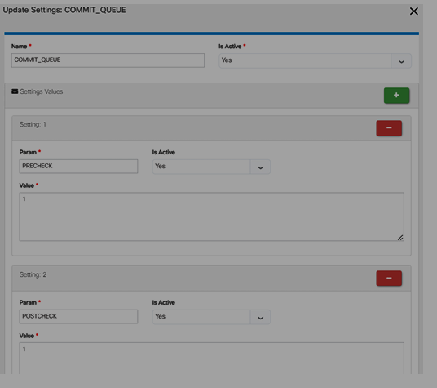
Playbook Test cases dashboard. Playbook Test cases dashboard provide you the list of available testcases, user can add appropriate test cases as per his requirements.
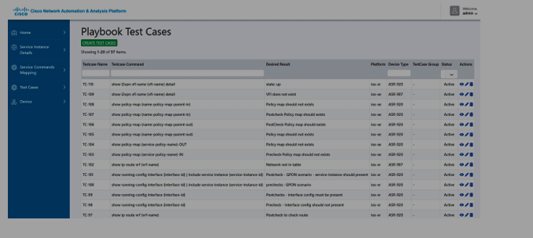

12.6.3 Service Command Mapping. Service command mapping dashboard enable you to map precheck and postcheck commands to Sub Service Id.
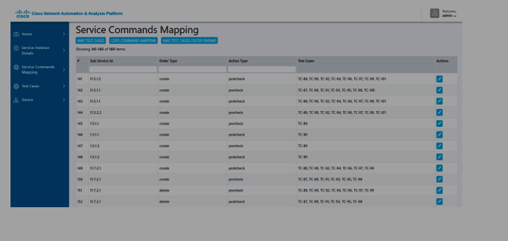
Playbook Devices. Playbook Devices dashboard enable you to add device on playbook platform. Which will use to run mapped commands on that devices
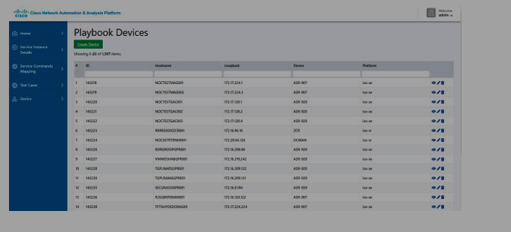
12.6.5 Service Instance Details
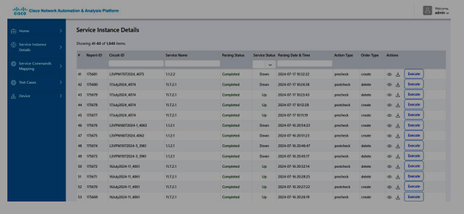

- Appendix

  - Service Templates

